Welcome to
Oaklands School
2025-26

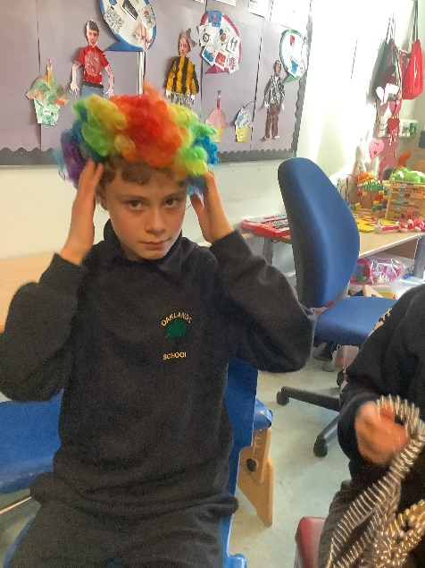
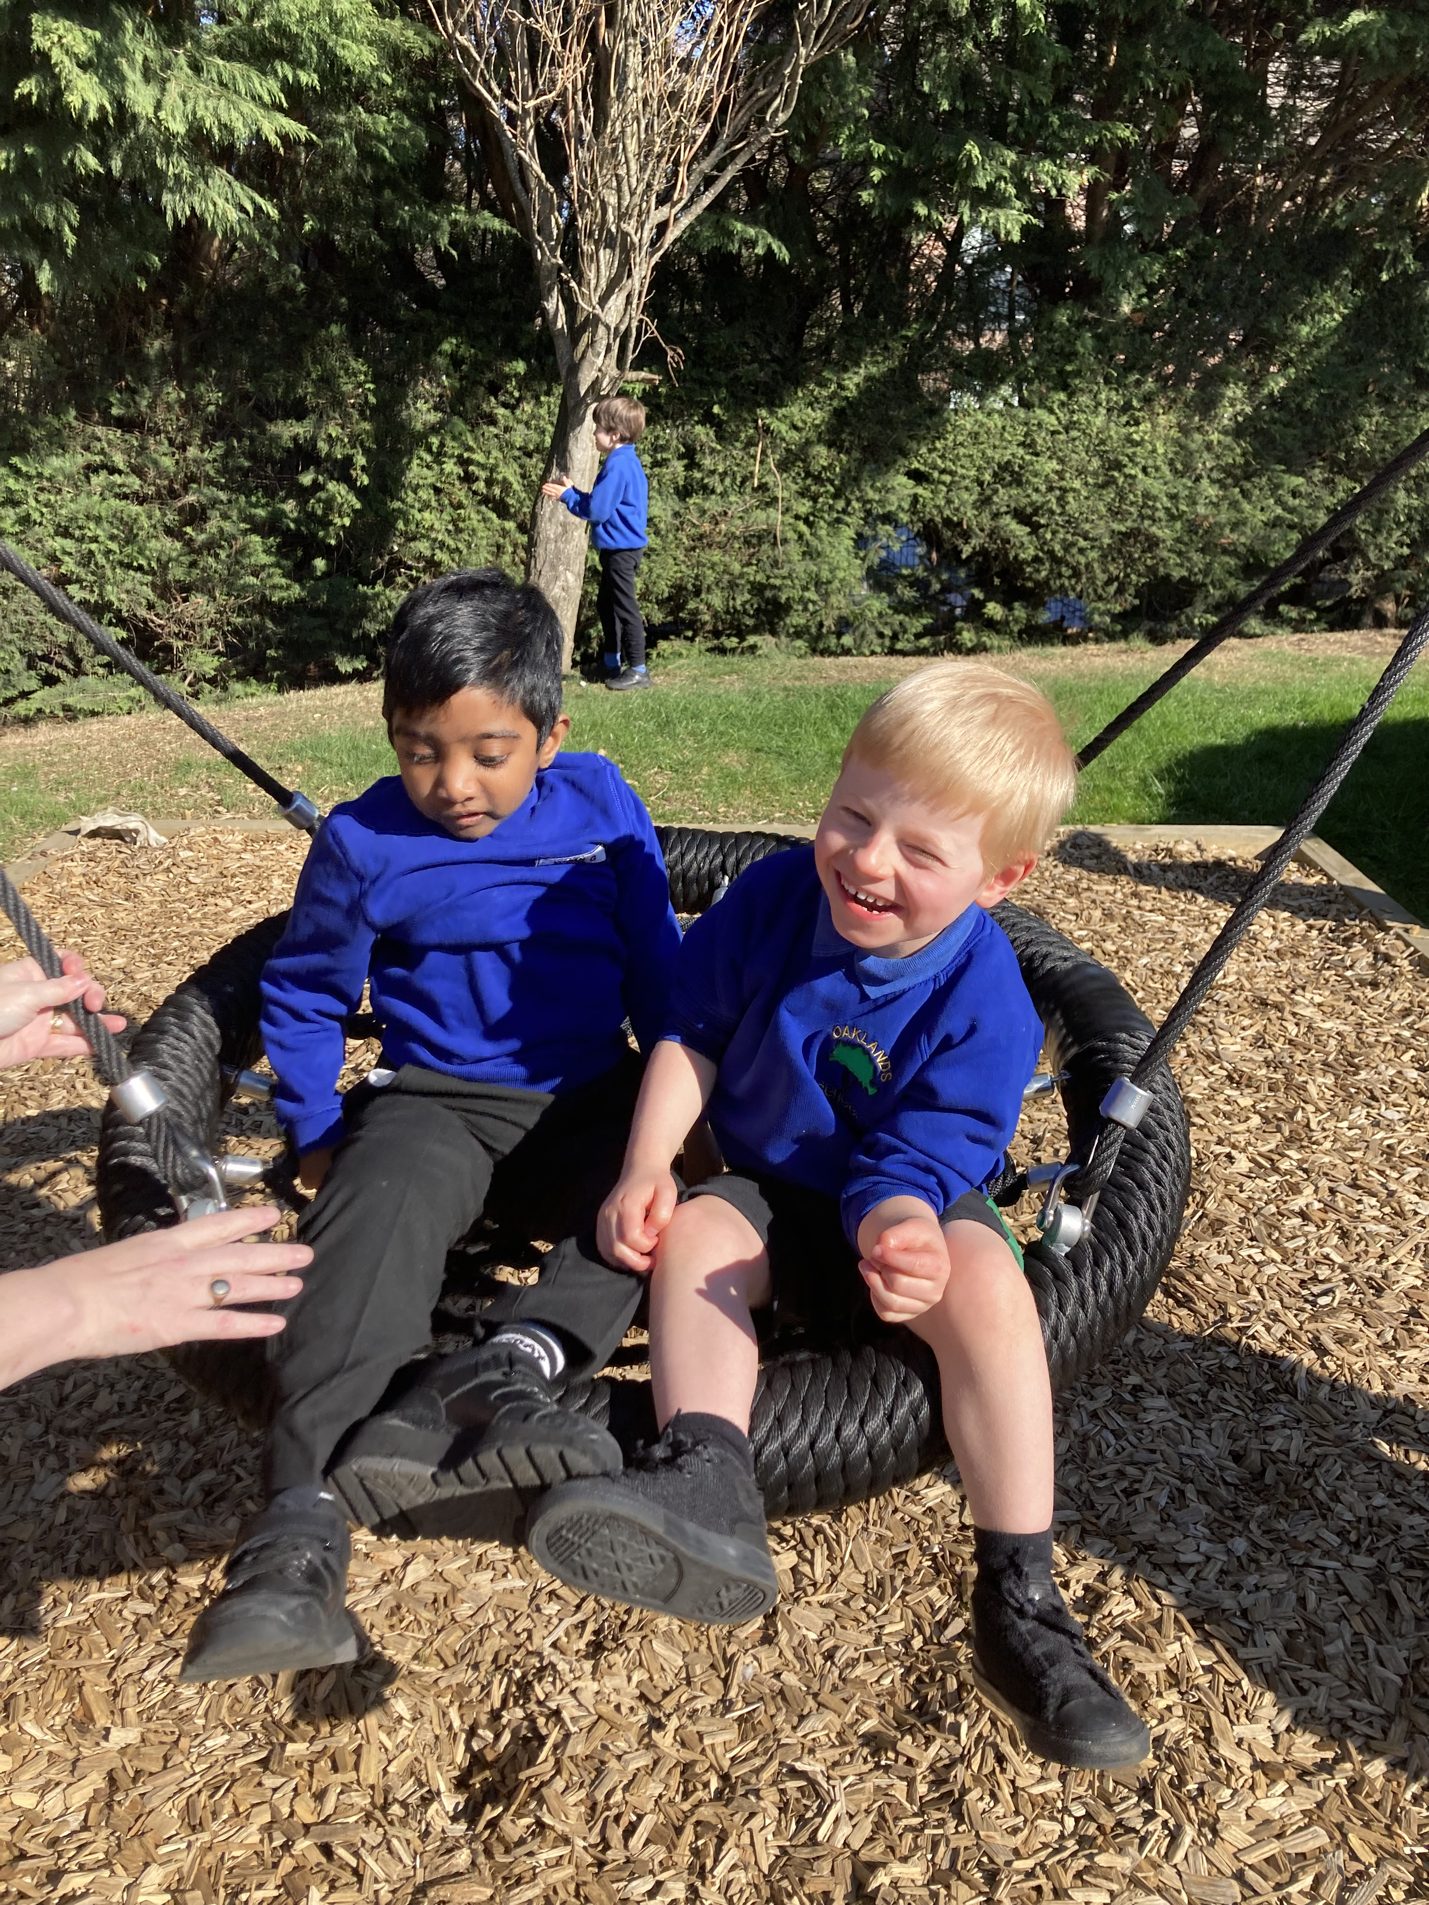

A place where we support our children to dream big, go far, and unlock their potential.

@Team_Oaklands.bsky.social

Oaklands School
750 Ferry Road
Edinburgh
EH4 4PQ

Tel: 0131 315 8100
Email: admin@oaklands.edin.sch.uk
Website: www.oaklandsedinburgh.com



0131 315 8100 www.oaklandsedinburgh.com @Team_Oaklands.bsky.social
Contents
- Foreword from the Executive Director of Education, and Children’s Services p. 3
- Head Teacher welcome p. 4
- Family Link Worker information p. 5-6
- School contacts, school roll, school day p. 7
- Aims, Vision and Values p. 8-10
- About our school p. 11
- Allied Health Professionals p. 12
- School staff p.13
- Term Dates p. 14
- Admission criteria p. 16
- Admission arrangements p.16
- Absence and Emergency Contacts p. 16
- Additional Support Needs p. 17
- Assessment p. 17
- Closures p. 17
- Clothing and Footwear, Communication p. 18
- Signing Systems p. 19
- Promoting Positive Behaviour p. 19
- Getting it Right for Every Child, Child Protection p. 20
- Preventing and Responding to Bullying and Prejudice Behaviours p. 21
- Complaints, Comments and Suggestions Procedure p. 21
- Curriculum p. 22
- Individualised Educational Programmes p. 23
- Medical Arrangements p. 23
- MOVE p. 24
- Nursery Class Provision p. 24
- Parent Engagement p. 25-26
- Locality groups and the citywide Special Schools Group p. 26
- Holiday Support p.26
- Post School Provision p. 27
- Religious Instruction and Observance p. 28
- Rights Respecting Schools p.28
- Security p. 29
- School Meals p.29
- School Uniform p. 30
- Health & Safety p. 30
- Swimming p. 31
- Transport p. 31
- What’s Happening at Oaklands p. 32
- Useful Contacts and information p. 33

A Foreword from the Executive Director of Education, and Children’s Services

Dear Parents/Carers,

This brochure contains a range of information about your child’s school which will be of interest to you and your child. It offers an insight into the life and ethos of the school and also offers advice and assistance which you may find helpful in supporting and getting involved in your child’s education.

We are committed to working closely with parents and carers as equal partners in your child's education, in the life of your child's school and in city-wide developments in education.

Parental involvement in the decision making process and in performance monitoring are an integral part of school life. We look forward to developing that partnership with your support.

Throughout this handbook the term ‘parent’ has the meaning attributed in the Standards in Scotland's Schools Act 2000 and the Scottish Schools (Parental Involvement) Act 2006. This includes grandparents, carer, or anyone else who has parental responsibility for the child.

I am pleased to introduce this brochure for session 2025 - 2026 and hope that it will provide you with the information you need concerning your child’s school.

If you have any queries regarding the contents of the brochure, please contact the Head Teacher of your child’s school in the first instance who will be happy to offer any clarification you may need.

Amanda Hatton

Executive Director of Children, Education and Justice service

Education, and Children’s Services Vision

Our vision is for all children and young people in Edinburgh to enjoy their childhood and fulfil their potential.

We believe that children and young people do best when:

- they are able to live safely and happily within their own families with the right kind of support as needed
- they attend first class, inclusive schools and early years settings which meet their needs

We will do all we can to strengthen support for families, schools and communities to meet their children's needs.

Our mission is to place children, young people and families at the heart of our service and provide support when it is needed throughout childhood and the transition to adulthood.

0131 315 8100 www.oaklandsedinburgh.com @Team_Oaklands.bsky.social


Welcome from the Head Teacher

Rebecca Vaughan
Head Teacher
Dear Parents, Carers, and Friends of Oaklands,
Welcome to our school handbook for the 2025/2026 session!
Oaklands is a truly special place — a vibrant school filled with remarkable children and young people, supported by a dedicated and compassionate team of staff. We hope that, whether you’re visiting us in person, exploring our website, or reading through this handbook, the spirit of our school comes through clearly.
At Oaklands School, we provide education for children and young people with complex, long-term additional support needs. Our learners require a highly adapted learning environment, as the presumption of mainstream education cannot be met.
Our pupils have profound and multiple learning disabilities, often with associated — and sometimes life-limiting — healthcare needs. Many have significant physical disabilities and are wheelchair users. Our school and its grounds are fully accessible, ensuring that all of our learners can participate fully in school life.
The beginning of a new school year always brings excitement and hope. We’re looking forward to another successful year of learning, growth, and achievement for all our pupils and families. Throughout the year, we come together as a school community to celebrate our pupils' achievements and host social events for families — we warmly invite you to join us whenever you can.
We understand that challenging times can place additional pressure on families, and we want you to know that we’re here to support you. Please don’t hesitate to contact me directly, or reach out to Aryadaya (DHT – Monday/Friday) or Clare (DHT – Tuesday to Thursday), via the school office if you need any support or further information.
We regularly update our website and our Bluesky feed (@Team-Oaklands) to give you a window into daily life at Oaklands and to keep you informed of what’s happening across the school
It is a genuine privilege to serve as Head Teacher of this incredible school community. I look forward to working closely with you throughout the year to ensure your child or young person has a happy, rewarding, and meaningful experience at Oaklands.

Warm regards,
Rebecca Vaughan
Head Teacher
August 2025

0131 315 8100 www.oaklandsedinburgh.com @Team_Oaklands.bsky.social
Family Link Workers

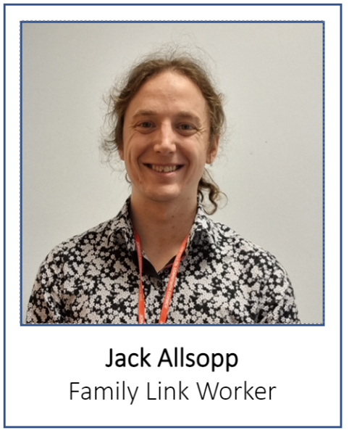
Hello! My name is Jack Allsopp, and I am the family link worker at Oaklands. Having worked in the school for a number of years, I recently got the opportunity to be able to support our students in a new way! My job is to be an advocate, a listening ear, and a helping hand to all the Oaklands families. You can contact me with anything you want or need Nothing is too small or too large, and there will never be any judgement. I look forward to hearing from you!
I can help with any issues that affect the children and their families, for example:
- Sign-post parents/carers to relevant services
- Assist with form-filling
- Support you with accessing benefits and welfare claims
- Make contact with various organisations
- Be a supporting and listening ear.

Make sure to keep an ear and eye out for events and opportunities that we share with you via email and text! These can include our very popular parents’ social days, sports and holiday activities, funding opportunities, school events and much more.
If you have any thoughts, queries or concerns you would like to speak to me about, I can be contacted at Jack.allsopp@oaklands.edin.sch.uk or call the school on 0131 315 8100.

Rachela Klimczewska
Family Link Worker (Transitions)

Hello! My name is Rachela Klimczewska, and I am a Transition Support Family Worker here at Oaklands.

I joined Oaklands in January 2022, having worked in mental health and a learning disability nursing role for a few years prior to working here. I have always been quite passionate about advocating for the people I work with, and I am very excited to be able to use those skills to help the older pupils at Oaklands who are transitioning into adulthood.

My role at Oaklands is fully dedicated to transitions, and I would like to assure you that I will do my absolute best to support you and your child in their final years at Oaklands. Please feel free to get in touch with me at any time by emailing: Rachela.Klimczewska@oaklands.edin.sch.uk

Please continue on to the next page to find out more about an exciting project Jack and I are currently working on as a team.

0131 315 8100 www.oaklandsedinburgh.com @Team_Oaklands.bsky.social
Communication Passports for All Pupils

Communication passports are important for children with disabilities because they help others understand how to connect with them, and how to best support them. These passports share the child’s likes, dislikes, and special ways of communicating. They also provide information about the child’s support needs, the equipment they use, and more!
Communication passports help make sure that everyone knows how to support the child in a way that feels comfortable and safe and brings the best results.
With a communication passport, the child’s voice is heard, making them feel valued and included.

The Family Link Workers team are currently working on rolling communication passports out to as many Oaklands pupils as possible.

The templates we use at Oaklands School are the PAMIS passport (https://pamis.org.uk/services/digital-passports/) and the COMMPASS (https://mycommpass.com/about/) depending on the child’s needs.
We will be happy to meet with you and show you a sample communication passport and talk you through the benefits of having one. We will also be able to help with creating this document.
We will invite parents to meet with us when we begin working on their child’s document. Although we plan to work our way through the list of pupils, if you would like to start sooner and don’t want to wait, please get in touch with us. We will be more than happy to help.
Below is an example of several pages from a PAMIS passport for a fictional person.
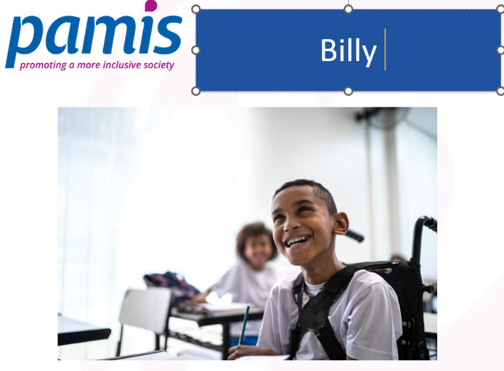
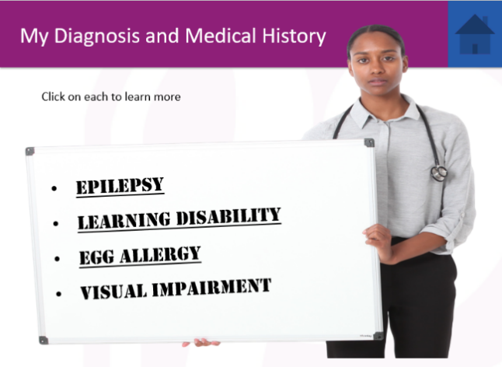
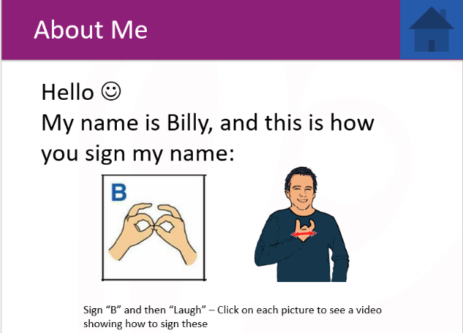

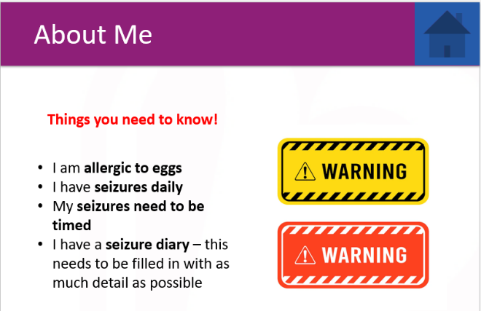
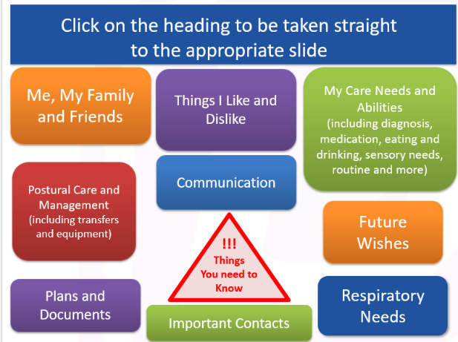

0131 315 8100 www.oaklandsedinburgh.com @Team_Oaklands.bsky.social

Contact Details:
Name of Head Teacher Rebecca Vaughan
Name of School Oaklands School
Address 750 Ferry Road, Edinburgh, EH4 4PQ
Telephone Number 0131 315 8100
Website www.oaklandsedinburgh.com
Bluesky @team-oaklands.bsky.social
Email Address Rebecca.Vaughan@oaklands.edin.sch.uk

About the School:
Stages of Education provided for:  Present Roll:  Denominational Status of the School (if any):  Gaelic Medium Education if relevant: | Nursery-S6  62  N/A  N/A

Usual Organisation of the School Day
Start Time:  Morning Break:  Lunch Time:  Afternoon Break:  Finish Time: | Nursery- 08.54am  Primary/Secondary – 9.00am  N/A (breaks taken as and when pupils require them)  Pupil and Staff lunches run from 11.30am-2.00pm  N/A  Mon-Thurs -3.00pm for primary  Mon-Thurs- 3.30pm for nursery/secondary  Friday- 12.30pm (all departments)

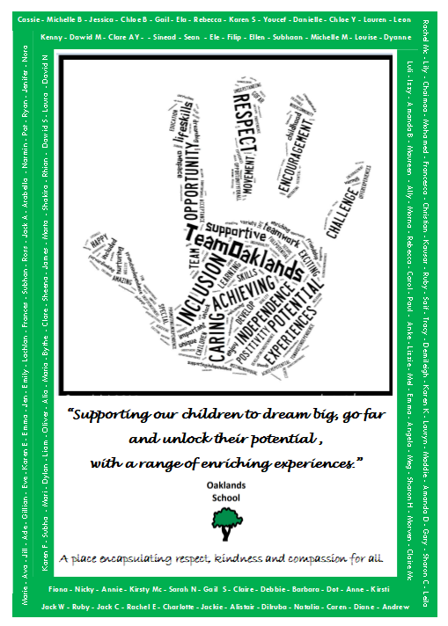
0131 315 8100 www.oaklandsedinburgh.com @Team_Oaklands.bsky.social
“A place where we support our children to dream big, go far, and unlock their potential.”
Our School Vision

0131 315 8100 www.oaklandsedinburgh.com @Team_Oaklands.bsky.social
Oaklands Aims - Updated March 2025

A place encapsulating respect, kindness and compassion for all.

OUR VALUES:
- We nurture our learners, staff, parents and partners as central parts of our vision, values and ethos of Oaklands School.
CURRICULUM:
- We develop a broad and balanced curriculum with an individualised approach that meets the needs of children and young people with complex needs, allowing them to achieve their full potential through a variety of enriching experiences.
CHILD OR YOUNG PERSON AT THE CENTRE:
- We use inclusive communication; experiential learning and technology to ensure our children and young people are nurtured and supported to develop their full potential.
We value their contribution and ensure our children and young people are encouraged to develop their own voice.

PARTNERSHIP:
- We value the contributions of our school community – learners, parents, staff and therapists - by ensuring that individualised targets are created, shared, evaluated and updated with input from all stakeholders.
SKILLS:
- We value and promote skills for learning, life and work – recognising the significance of active participation and wider experiences in our local community – for enriching the lives of our children and young people.
ACCREDITATION:
- We create and develop a multi-sensory curriculum including the MOVE Programme, Visual and Hearing Impairment support and opportunities for personal achievement such as participation in National Qualifications, Duke of Edinburgh and JASS.
COMMUNITY:
- We foster a sense of belonging in our local community, as a valued partner and as active participants in our local area.
WHAT WE DO:
- We embed, enshrine and celebrate health and wellbeing, diversity and equality as the key principles of our school community and as the founding values upon which we develop strong relationships and a sense of belonging.

0131 315 8100 www.oaklandsedinburgh.com @Team_Oaklands.bsky.social

Inclusiveness.
Everyone is treated equally, regardless of their additional needs, race, sex or religion.

Ambition.
We are ambitious and hold high aspirations for our pupils. We will always help them to be the best they can be.
Dignity.
Everyone is treated with the dignity and respect we would ask for ourselves or our family members.

Oaklands School Values
“Aplace where we support our children to dream big, go far
and unlock their potential.”

Excellence.
We strive for excellence in every aspect of our school day and from everyone in our school..
Kindness.
Everyone is treated with kindness and compassion whether a pupil, a member of staff, or a member of our wider school community.

Welcoming.
Everyone is made to feel welcome in our school whether a pupil, staff member, parent or someone who is part of our wider community.

0131 315 8100 www.oaklandsedinburgh.com @Team_Oaklands.bsky.social

About Our School
Oaklands School provides education for children and young people with complex, long term additional support needs who require a significantly modified learning environment. Needs of learners are primarily associated with learning disability and significant visual / sensory, health and medical needs.

The school serves a wide area with pupils attending from throughout the City of Edinburgh and the Lothians.

In 2006, Oaklands School moved to its present location on Ferry Road. It is a purpose-built building on one level which caters for children and young people from 3 - 18 years.

Facilities include a hydrotherapy pool, soft play room and multi-sensory room as well as dedicated music, VI and Home Economics rooms. An overhead tracking system means that all rooms are accessible for children in wheelchairs. There are medical and dental treatment rooms. A dentist and dental hygienist regularly visit the school.
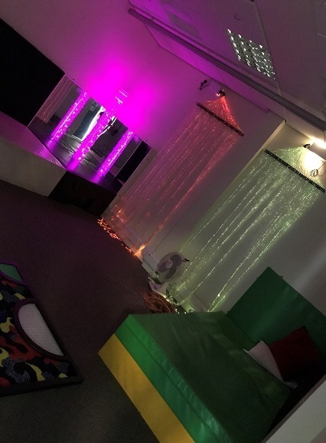
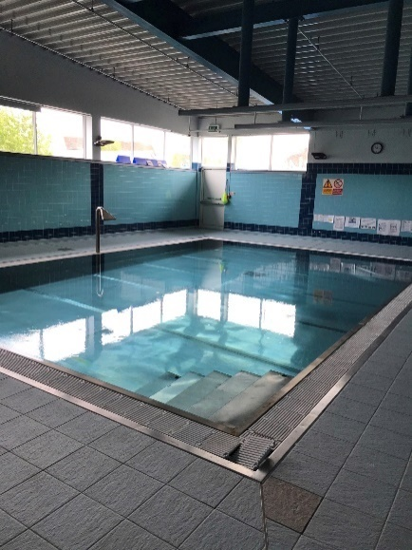
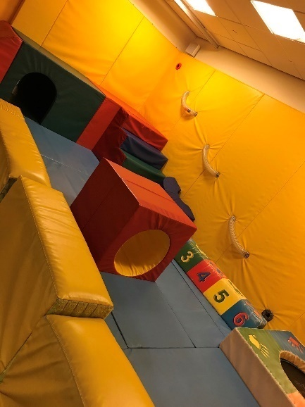

Keycomm, a citywide resource, exists to help people with communication impairments, make use of technology to contribute to and control their environment. This resource is based in and used extensively by our school.
Classes
This year we have 1 Nursery Class, 4 Primary classes, 4 Secondary classes. Classes are small, (a maximum of 8 pupils), with a high pupil to staff ratio which ensures the needs of our children and young people are met.
Typically, a class team might consist of 1 teacher, 1 Nursery Nurses and 2-3 Pupil Support Assistants.
The school currently has a role of 62 pupils.

School Hours – Monday to Thursday: School Hours Friday
Nursery 8.54am – 3.30pm Nursery 8.54am – 12.30pm
Primary 9.00am – 3.00pm Primary 9.00am- 12.30pm
Secondary 9.00am – 3.30pm Secondary 9.00am – 12.30pm

0131 315 www.oaklandsedinburgh.com @Team_Oaklands.bsky.social

Allied Health Professionals
Due to the complex needs of many of our children and young people, we have several health services based at Oaklands. We have Nursing staff, Physiotherapists, Speech and Language Therapists and Occupational Therapists based at the school.
The dentist and community paediatricians hold regular clinics in school.
Our allied health professionals are critical parts of Team Oaklands. We love working with them. They know our pupils extremely well and they are integral to ensuring that all the needs of our children and young people are met.

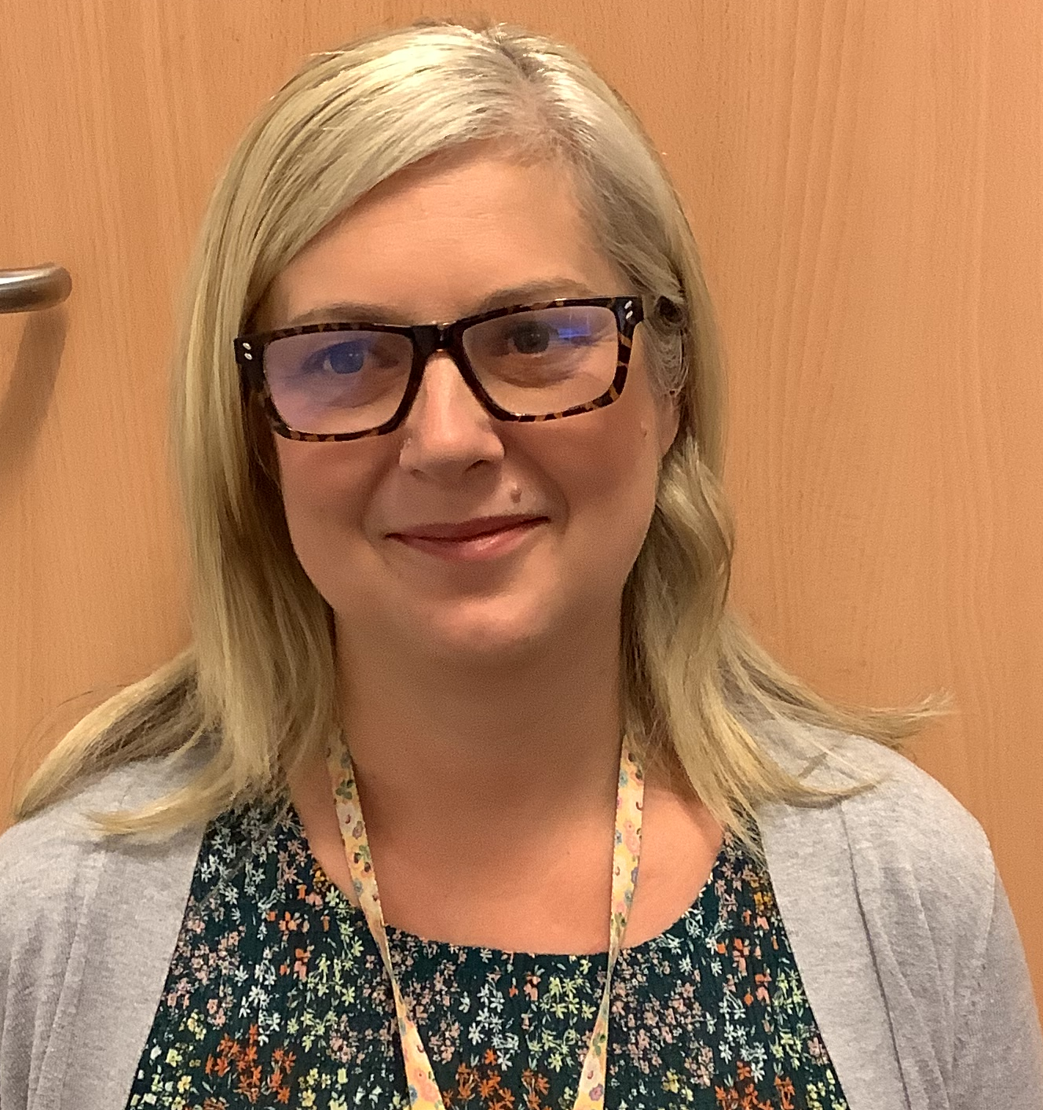
Louise Cowpe
School Nurse

Claire Campbell
School Nurse
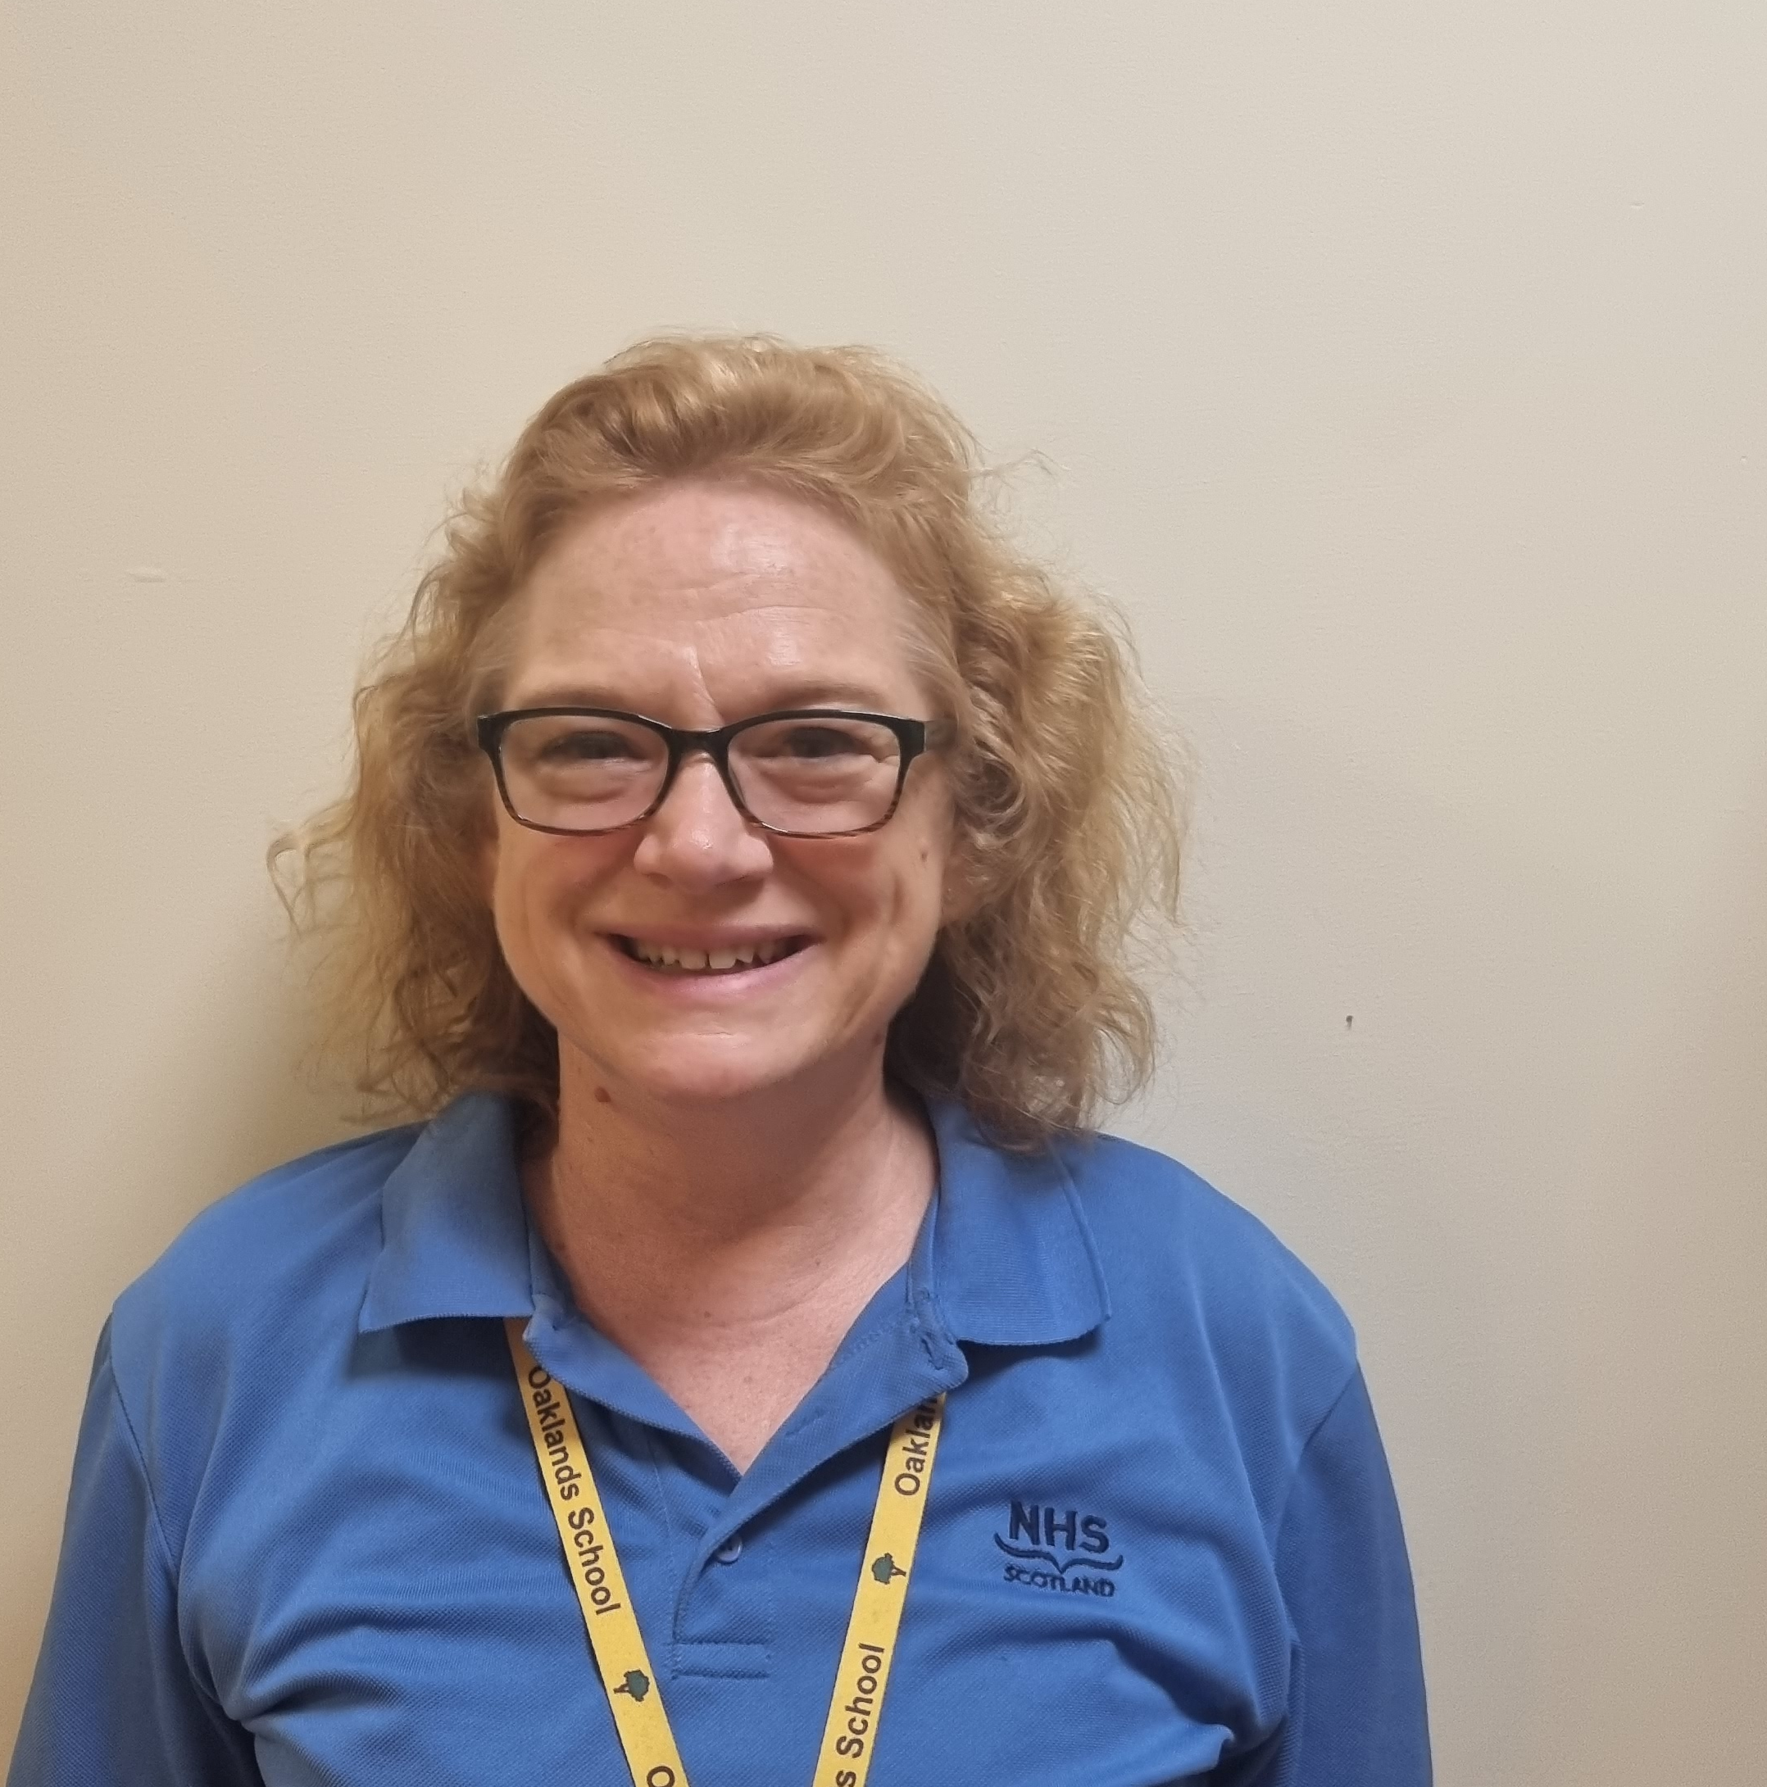
Kerry Brown
School Nurse
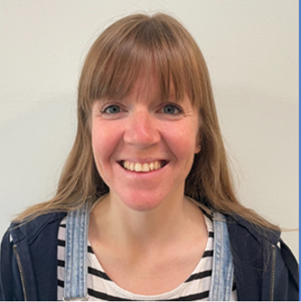
Louise Bowers
School Nurse

You can contact our nurses via our school office at 0131 315 8100
or on 0131 315 8105
You can contact the therapy base via the school office at 0131 315 8100 or on 0131 315 8106


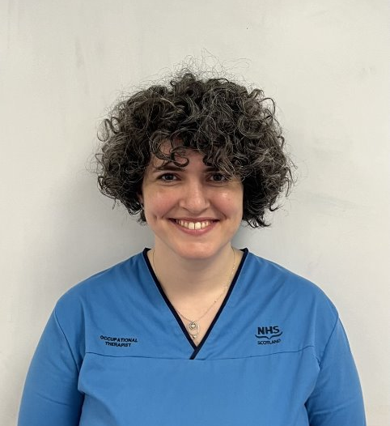

Kate Owen
Occupational Therapist

Sarah Clark
Speech and Language


Arlene Oaks
Speech and Language Assistant
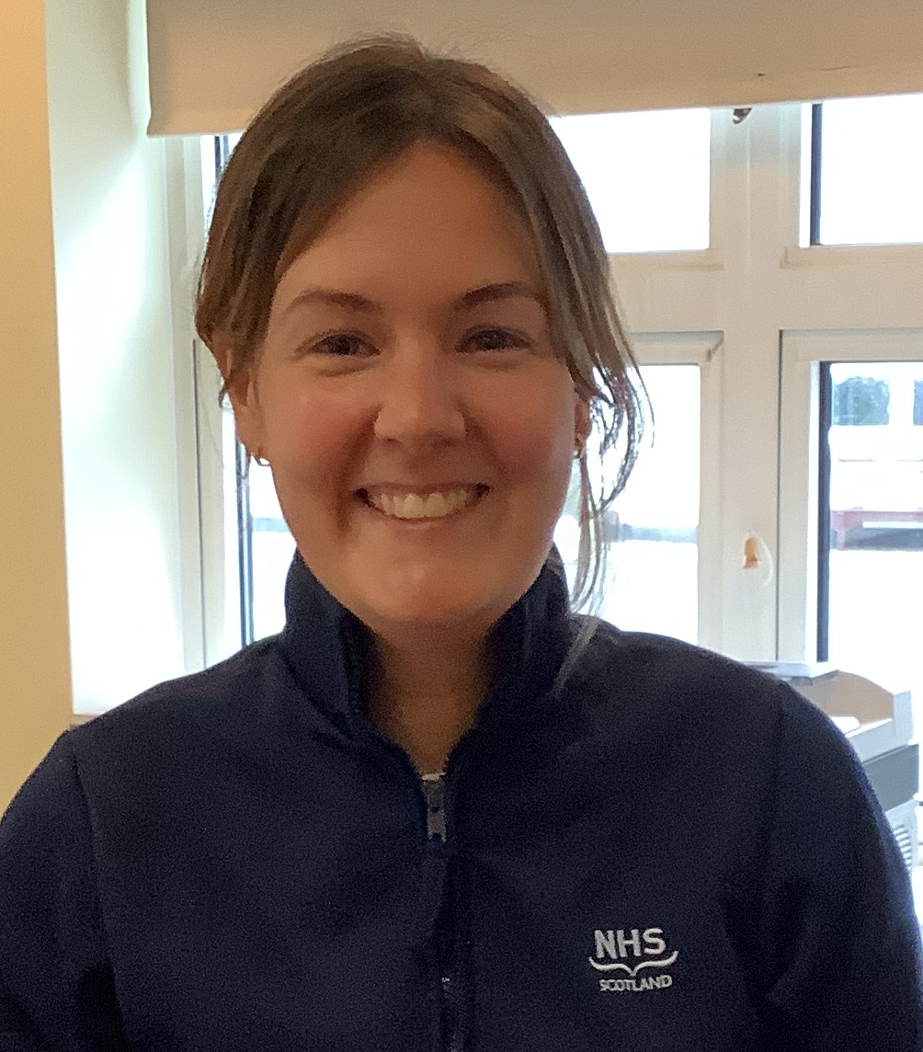
Amy Newton
Occupational Therapist

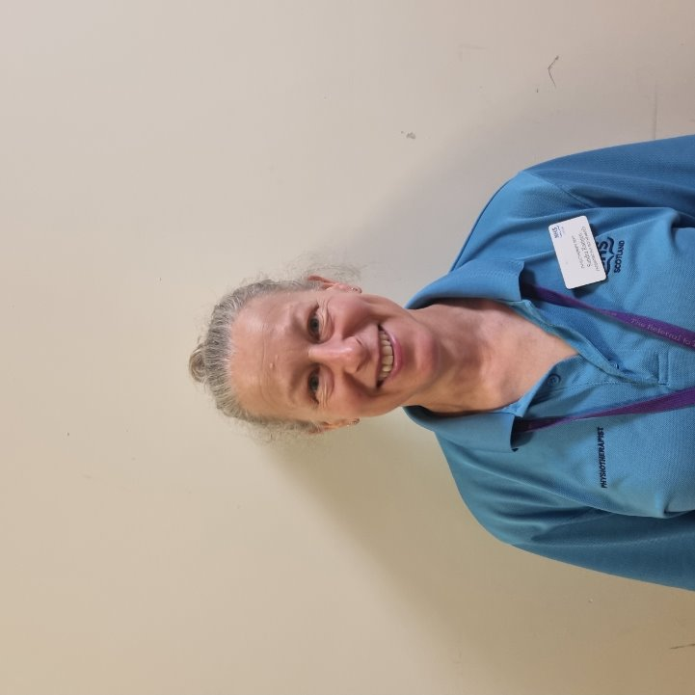
Sandra Rathjen Physiotherapist



Graham Clark
Physiotherapy assistant

0131 315 8100 www.oaklandsedinburgh.com @Team_Oaklands.bsky.social

School Staff – Session 2023/24

Management Team: Head Teacher Rebecca Vaughan

Rebecca Vaughan
Head Teacher
Depute Head Teachers Aryadaya Thomson (acting) (Mon, Fri)

Clare Warwick (Tue, Wed, Thur)
Business Manager Gillian Bruce
Principal Teacher Aryadaya Thomson (Tue, Wed, Thur)

Class Teachers: Holly Stewart Hoehnke
Pine Sarah Connolly
Willow Debbie Ward/Morna Phillips

Clare Warwick
Depute HT

Maple Nancy Dundas
Spruce Jill Richardson
Rowan Gwen Twynam Perkins
Beech Peter Verrechia
Aspen Corbin Sharp
Nursery SEYO Lauren Kenny

Specialist Teachers: Performing Arts Angela Harrison
Jacqueline Wheble

Aryadaya Thomson
Depute HT

Sports Coach: Sharon Humble (Mon, Tue, Wed)

MOVE Coordinators: Debbie Ward, Dyanne Mudie

Administrator: Jo Drever

Family Link Worker: Jack Allsopp, Rachela Klimczewska (Transitions)

SSO: Paul McKellican

Kitchen Supervisor: Barbara Masterson

School Nursing Team: Claire Campbell, Kerry Brown, Louise Bowers, Louise Cowpe, Ruth Neville

Consultant Community Paediatrician: Nicola Wright (Vision)

Physiotherapy Team: Sandra Rathjen, Melanie MacLennan, Graham Clark

Speech and Language: Jo Gratton-Shanks, Sarah Clark, Arlene Oakes

Occupational Therapy Team: Amy Newton, Kate Owens,

Chair Parent Council: Jane Geddes
Vice Chair Parent Council: Vacancy

Support Staff: We have a team of Nursery Nurses and Pupil Support Assistants supporting classes across the school.

0131 315 8100 www.oaklandsedinburgh.com @Team_Oaklands.bsky.social

Term Dates
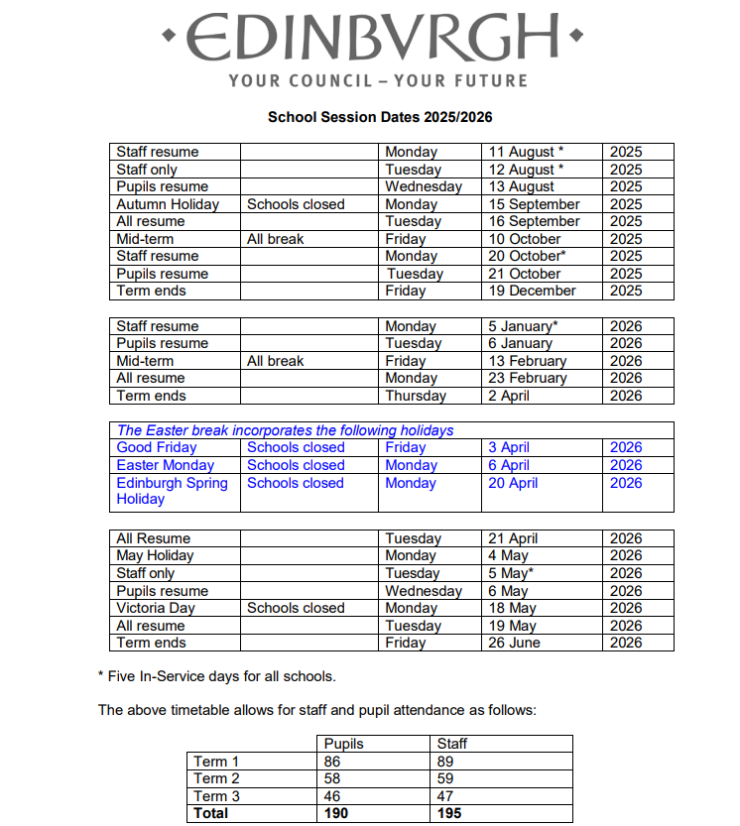

0131 315 8100 www.oaklandsedinburgh.com @Team_Oaklands.bsky.social

Admission Criteria
Oaklands school provides education for children and young people with complex, long term additional support needs where the presumption of mainstream cannot be met and require a significantly modified learning environment. Needs of learners are primarily associated with learning disability and significant visual / sensory, health and medical needs.

Pupil needs may be complex and may include sensory impairments, speech and language delay, physical disabilities and other health needs.

We can currently best offer an education to:

- Children who need a SMALL GROUP setting offering a high pupil: staff ratio.

- We aim not to exceed a ratio of approximately 1:1.5 (i.e. 5 staff and 7 or 8 children).

- Typically, our children have very high support needs, requiring 1:1support at times. Some will need the attention of 2 or 3 staff for positioning and almost all require support with personal care and to ensure that their basic needs are met.

- Pupils need space for equipment and for appropriate activities so that room size also controls the size of the teaching group.

- Pupils need highly detailed Individualised Educational Programmes requiring high staff ratios to support an individual approach throughout the day.

- Many of our pupils have life lasting healthcare needs and health related conditions that may vary every day, such as epilepsy. Because of this, we offer close observation and a highly flexible, responsive and personalised programme.

- Children who need a very strong and well-co-ordinated multi-disciplinary network on site.

The multidisciplinary team in Oaklands includes:
- Education staff
SALT
- Family Link Worker
Education
- Nurses
- Physiotherapists
- Speech and Language therapists
Nurses
Physiooos
- Occupational Therapy
- School doctor and consultations with a paediatrician
- In-house qualified support for visually impaired pupils
The individual expertise of the members of the multi-disciplinary team contributes to the depth and breadth of support for pupils. The whole team can support less experienced members – ensuring that overall service quality remains high.

0131 315 8100 www.oaklandsedinburgh.com @Team_Oaklands.bsky.social
Admission Arrangements
Enquiries about admission should be through your child’s Educational Psychologist.
Interested parties, however, are welcome to contact the Head Teacher for information that might help them to decide about the placement of their child. They are also very welcome to come to Oaklands and visit the school.
As Oaklands is a school for pupils with additional support needs, admission will be by assessment by the City’s specialist advisers in consultation with parents and consideration by the appropriate Professional Assessment Group.


Absence and Emergency Contact
Please keep your child away from school if they appear unwell. This helps to keep down the level of minor infection in school. Please notify us on the first day of absence before 9am.

We may need to contact you if your child is sick in school or if there is an emergency closure of the school. Please make sure that we always have an up-to-date telephone number and an emergency contact in case you are not at home.

Absence and Holidays

Please make every effort to avoid family holidays during term time as this will disrupt your child’s education and reduces learning time. The head teacher can approve absence from school for a family holiday in certain extreme situations, for example, in traumatic domestic circumstances where the holiday would improve the cohesion and wellbeing of the family. Please discuss your plans with me before the holiday.

If permission cannot be given before the holiday, it will be recorded as unauthorised absence. Holidays can be authorised if you can prove that work commitments make a family holiday impossible during school holiday times. Normally, your employer will need to provide evidence of your work commitments. Absence approved by the head teacher on this basis is regarded as authorised absence.

Any requests for extended absence over two weeks will be referred to the Senior Education Manager: Inclusion who will decide if it will be recorded as authorised or unauthorised leave.

Parents may request that their children be permitted to be absent from school to celebrate recognised religious events. Absence approved on this basis is regarded as authorised absence. Extended leave can also be granted on request for families returning to their country of origin for cultural or care reasons.

A supportive approach is taken to unexplained absence. However, the Education and Children’s Services department has legal powers to write to, interview or prosecute parents, or refer pupils to the Reporter to the Children’s Panel, if necessary.

0131 315 8100 www.oaklandsedinburgh.com @Team_Oaklands.bsky.social

Additional Support Needs

An additional support need comes from anything that is a barrier to learning. All children in special schools have additional support needs. The education authority has many legal duties towards pupils with additional support needs. Information about this is contained in a booklet called In On The Act: Information For The General Public which is published on the education authority website at www.edinburgh.gov.uk/inontheact - or contact the additional support for learning team on 0131 469 3444.

Pupils who attend Oaklands School tend to have learning disabilities that are more complex and, often, health related needs.


Assessment

As pupils’ progress through our school, teachers use a range of assessment strategies, including Assessment for Learning strategies.

We recognise that all pupils do not develop and progress at the same rate and, therefore, we use both group and individual methods to ensure that all pupils are given the opportunity to succeed.

Pupil progress is recorded in the pupil’s IEP and an annual report is written by the pupil’s class teacher. Therapists working with pupils also present parents with a Supported Learning Profile, which is updated annually. Parents are then invited to a Pupil Planning meeting to discuss future learning objectives for their child.

Closures

In the event of an emergency, such as a power cut or severe weather, that prevents schools from opening in the morning or results in an early closure, a range of channels of communication are used to inform parents.
We will use Groupcall messenger alert system to contact parents. Please make sure we have your most up-to-date information at school, so you do not miss alerts.

We will all post the most up to date information on our school Bluesky and website:

@Team-Oaklands.bsky.social www.oaklandsedinburgh.com

In addition, announcements will be made on Radio Forth (Forth 1 and Forth 2) and via the Council's corporate Twitter account www.twitter.com/Edinburgh_CC and Facebook page www.facebook.com/edinburghcouncil. If many schools are affected, or the situation is likely to be prolonged, then the Council's website www.edinburgh.gov.uk will also be used.

0131 315 8100 www.oaklandsedinburgh.com @Team_Oaklands.bsky.social

Clothing and Footwear Grants

Jack Allsopp, our Family Link Worker can help – 0131 315 8100 or Jack.Allsopp@oaklands.edin.sch.uk


Grants for footwear and clothing for children are available to parents receiving:

- Child Tax Credit, but not Working Tax Credit, and your income is less than £19,995
- Universal Credit (where your monthly earned income is less than £796)
- Income support
- Jobseekers allowance [income-based]
- Support under Part VI of the Immigration & Asylum Act 1999
- Income -based Employment and Support Allowance
- Both Child Tax Credit and Working Tax Credit and have an income of up to £9,552

Applications for clothing grants can be made by contacting Grants, Awards and Placements, Business Centre 1:1 Waverley Court, 4 East Market Street, Edinburgh, EH8 8BG or on the council website: www.edinburgh.gov.uk/schoolgrants

Communication
Inclusive Communication for all - Learners and their families

In Oaklands, the development of communication skills is of paramount importance to help enable all pupils to access other areas of the curriculum and allow social inclusion in school, at home and in the wider world.

The class teacher works with the speech and language therapist, support staff and the child’s parents to complete assessments to establish how the child communicates and what communication aids need to be put in place to help progression.

The speech and language therapist will base her assessments on observations in class and may provide communication aids for home/school use as well as in the classroom.

We use an ‘Inclusive Communication Environment’ to help all the pupils in school to develop an understanding of what is happening around them. A full explanation of this can be found in a separate Oaklands policy document entitled “Our Inclusive Communication Environment”.

The pupils experience song cues, object signifiers and “on-body” or Signalong signing systems used together to help them to begin to build an awareness of the sequence of daily activities.

Have a look on our website to see the staff leading you through some song signifiers we use in school. They may be useful to use at home too. (www.oaklandsedinburgh.com)

0131 315 8100 www.oaklandsedinburgh.com @Team_Oaklands.bsky.social

Signing Systems

We base our signing systems on pupils’ natural gestures, as well as “on-body” signs, which include Canaan-Barrie signs, and the Signalong system. Only key words are signed e.g. up, down, more, finished. Signing may be “on–body” or “co-active” and each pupil will have a signing system that is personalised to meet their individual needs.

Promoting Positive Behaviour
Our pupils are unique individuals who have a range of complex health needs and learning difficulties. Many of them have difficulties with communicating their choices and feelings in an appropriate way.
Our teaching areas are organised in a way that helps pupils to make sense of their environment and to enable activities to run smoothly and successfully.

We encourage pupils to form positive relationships with their peers and with members of staff at the school and to express their feelings in a manner that is beneficial and helpful to them and to those around them.
At Oaklands, we use many ways to enhance communication…
- Home/school diaries

- Bluesky and the school website
- Family Link worker to support parents and carers
- Social events for families including ceilidhs and film nights
- Head Teacher’s newsletters
- Symbolised information
- Interpreters for reviews (where English is an additional language or British Sign Language)
- Information leaflets and support booklet for families
- Verbal support e.g. phone calls to families or Pupil Big Macs for messages between home and school
- Text communication for an adult who may be hearing impaired
- Large print for an adult who may be visually impaired
- Emails
- Text message alert
- Bag drop mail to parents
- Information events at school
- Families invited into school for training e.g. AAC, Signalong, how to help their child at home, MOVE
- Families invited to special assemblies and events.

0131 315 8100 www.oaklandsedinburgh.com @Team_Oaklands.bsky.social
Getting It Right for Every Child
Getting It Right for Every Child (GIRFEC) is the foundation for work with all children and young people, including adult services where parents are involved. It builds on universal health and education services, and is embedded in the developing early years and youth frameworks. Developments in the universal services of health and education, such as Better Health Better Care and Curriculum for Excellence, are identifying what needs to be done in those particular areas to improve outcomes for children.

Getting it right for every child aims to improve outcomes for all children and young people. It promotes a shared approach that:
- Builds solutions with and around children and families.
- Enables children to get the help they need when they need it.
- Supports a positive shift in culture, systems and practice.
- Involves working together to make things better.

Taking care of our children's well-being and making sure they are all right - even before they are born – helps us ensure the most positive outcomes for them later in life. It gives them the potential to grow up ready to succeed and play their part in society.

Oaklands adopts the Getting It Right for Every Child in Edinburgh approach to give the right help to children, young people and families, when they need it from a joined up multi agency team.

Child Protection

At Oaklands we follow the Edinburgh and the Lothians Multi-agency Child Protection Procedures. Details of these can be found on our school website. All school staff undertake regular Child Protection training in line with these procedures. Our Child Protection Coordinator is the Head Teacher, Rebecca Vaughan. Any child protection concerns should be directed to her in the first instance. If she is unavailable, please contact another member of the Senior Leadership Team. Out of school hours, urgent child protection concerns should be directed to Social Care Direct on 0131 200 2324 (Out of hours 0800 731 6969 after 5pm or before 8.30am or at weekends).

0131 315 8100 www.oaklandsedinburgh.com @Team_Oaklands.bsky.social

Preventing and Responding to Bullying and Prejudice Behaviour Among Children and Young People


City of Edinburgh Council updated their anti-bullying guidance in session 2020-21.
As an authority, we are committed to equalities and the wellbeing and protection of children and young people from bullying and prejudice. We work to prevent bullying and prejudicial behaviours and attitudes, and to develop positive relationships with all members of our school communities and wider partners. This work is part of our approach to Getting it Right for Every Child, creating communities that allow children to be Safe, Healthy, Active, Nurtured, Achieving, Respected, Responsible and Included.
As a school, we are committed to equalities and the wellbeing and protection children and young people from bullying and prejudice. Our school procedure is informed by the overarching ‘Preventing and Responding to Bullying amongst Children and Young People’ procedure. We recognise that policy and procedures alone will not address the prevention of bullying; through our core practices (Relationships, Rights Respecting, Resilience, Restorative) we aim to build positive relationships and a culture and ethos
which ensure respect, equality and inclusion. We promote an actively anti-bullying and anti-prejudice culture in our school through preventative, pro-active and responsive approaches.

Bullying and prejudice-based behaviours are not tolerated. The school will put in place appropriate support for all children and young people involved in a bullying or prejudice-based incident. We will support children who display bullying or prejudiced behaviour to identify the feelings and views that have caused them to act in this way. We will challenge these views and support children, through education and learning, to develop alternative ways of behaving. Working together with parents is an essential part of our approach to preventing and responding to bullying. When bullying or prejudice happen it is important that all parents involved work with the school to resolve the problems in the best interests of their child.

Complaints, Comments and Suggestions Procedure

We are very proud of our school and hope that hope that you will be completely satisfied with your child's education, and we encourage feedback on our services from parents and pupils. We are, therefore, interested in comments of all kinds, whether it be compliments, suggestions or complaints.

If you want to register a comment of any type about our school, you can do this by writing, emailing, telephoning or making an appointment to see someone. All feedback is welcome and keeps us in touch.

If, in particular, you have a complaint about the school, please let us know. It is better that these things are shared openly and resolved fairly, rather than being allowed to damage the relationship between the family and the school. At Oaklands we place the highest value on continued positive relationships with parents, so please do get in touch if you have a concern.
There will be no negative consequences arising from making a complaint and we will deal with the issue as confidentially as possible.

There are some things which you should take note of in relation to making a complaint:

- Please make any complaints initially to the Head Teacher. This makes sure that the school knows what is going on and has an opportunity to respond and resolve the issue.

- We will try to respond as quickly as possible, but often issues are complex, and we need time to investigate.

- If you are still unhappy with the service or with our response, then you will have the right to take the matter further and contact Advice and Conciliation [0131 469 3233].

- If you are still unhappy after the further investigation and reply, you can take the matter up with the Scottish Public Services Ombudsman, our reply will include the contact details.

0131 315 8100 www.oaklandsedinburgh.com @Team_Oaklands.bsky.social
Curriculum
At Oaklands, the basic aims of our curriculum are the same as in all schools and we acknowledge the broad principles of “Curriculum for Excellence”. We use Education Scotland’s Milestones, for pupils with complex needs to set individual targets.
Our curriculum, however, is specific to the needs of individual pupils and aims to provide a more flexible and enriched curriculum, which develops life skills and promotes experiential learning opportunities including sensory-based learning.
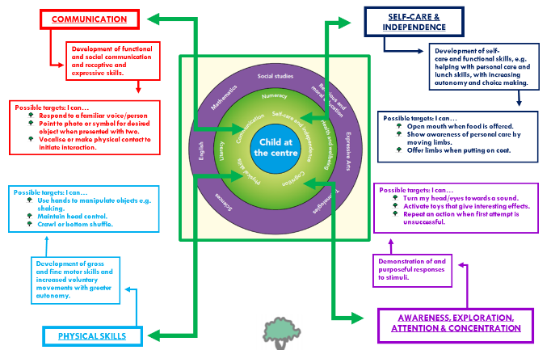
We focus on four key areas:
- COMMUNICATION

- SELF-CARE AND INDEPENDENCE

- PHYSICAL SKILLS

- AWARENESS, EXPLORATION, ATTENTION & CONCENTRATION

We use nationally recognised curricular programmes: JAS in the primary and Duke of Edinburgh and SQA curricular frameworks in the secondary, for all pupils and their progress and experiences are recorded and celebrated.
Senior pupils in the secondary achieve externally moderated certificates at all levels of ability. There are also strong links with Edinburgh College (Granton Campus), where pupils in their final years at school have opportunities to attend recreational courses as part of the leavers’ programme.
The Nursery Class use the Birth - 3 Framework, Realising the Ambition and Routes for Learning – promote early social interaction and communication. “Child at the Centre 2” is used as an evaluation tool.
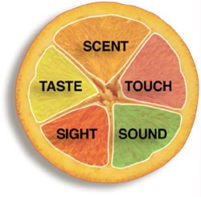
A sensory approach is used by the staff in Oaklands to enable pupils with multiple disabilities and a visual impairment (MDVI), to follow the same curricular programmes as their peers, offering a wide range of experiences through communication, personal and social development, information technology, expressive arts, home economics, science, hydrotherapy and movement.
These experiences are supported by individual therapy and sensory stimulation programmes.

0131 315 8100 www.oaklandsedinburgh.com @Team_Oaklands.bsky.social
Individualised Education Programmes

Each pupil in Oaklands has an Individualised Educational Programme (IEP). The learning outcomes in the IEP are prepared by teachers and therapists and discussed and agreed with parents/ carers at the annual pupil review meetings.
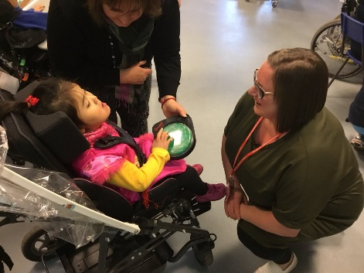
These learning targets are set within our four key focus areas:

- COMMUNICATION

- SELF-CARE AND INDEPENDENCE
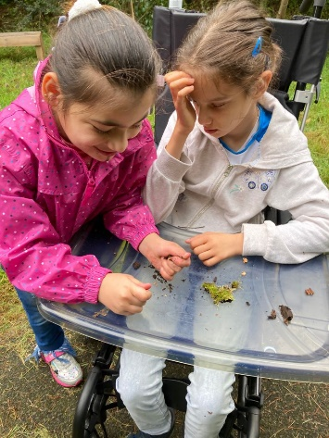
- PHYSICAL SKILLS

- AWARENESS, EXPLORATION, ATTENTION & CONCENTRATION

Medical Arrangements

Routine dental checks are carried out annually. The dentist and dental hygienist visit the school regularly and can provide advice to parents/carers on request. No treatment will be carried out without your permission.

The school doctor may carry out an annual medical review for some pupils to which parents/carers are invited. Nursing staff are also available for consultation. The School Doctor is made aware of any possible problems and parents/carers and the family doctor is informed if any further action is considered necessary.

School nurses are also involved with health promotion and education, prevention of ill health, immunisation, health surveillance and screening.

The school nurses link with other members of the health team, in the community or in hospital, concerned with a child’s health.

The school doctor or nurse will be pleased to see you and your child at a mutually convenient time if you are concerned about his/her health or general progress at school.

With your consent, the School Health Service Staff also carry out immunisations to protect against various diseases.

Any enquiries concerning the provision of dental services should be made to:
The Director of the Community Dental Service, 16 Duncan Street, Edinburgh, EH9 1SR
(Tel. 0131 667 7114).

Medicine Administration

At Oaklands, our school nurses administer prescribed and other medications to our pupils. Please keep the nurses supplied with necessary medication and inform them of any changes.

0131 315 8100 www.oaklansedinburgh.com @Team_Oaklands.bsky.social

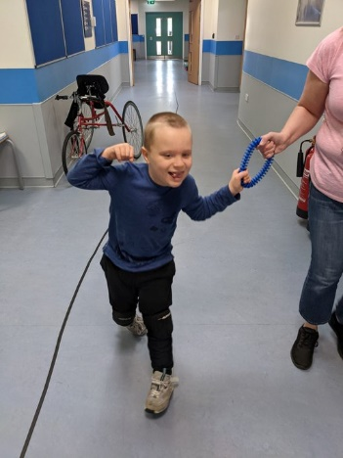
MOVE (Mobility Opportunities Via Education)

MOVE (which stands for Mobility Opportunities Via Education) is an activity-based programme, based on team working, which uses the combined knowledge of education staff, therapists and families to teach our children the skills of sitting, standing, walking and transferring to the best of their ability.

Using a goal-based approach the child works towards agreed goals and targets, which can vary and range from being able to raise and hold their head up independently, so they can access a communication aid to being able to walk unaided in their home or take steps in a walker, from going up and down stairs to walking on the grass in the garden. Each goal is aimed at teaching functional skills that the child will need as an adult to be as independent as possible.

The school uses appropriate teaching strategies with a wide range of equipment and resources. Parents receive information about the MOVE Programme and are closely involved with the assessment of their child and their goals and aspirations for their future development.

Oaklands School is firmly committed to following the practices of the MOVE programme. There is a dedicated MOVE Team in school, made up of two MOVE Coordinators; Debbie Ward and Dyanne Mudie who are also trainers, as well as some senior practitioners around the school. This small MOVE team supports the rest of the school staff in implementing MOVE and ensuring that our pupils can work towards their targets. All school staff are trained MOVE Practitioners. The MOVE team also work closely with the therapists as they are considered an integral part of the team around the child that supports them in working towards their skills.

We celebrate our children and young people’s MOVE successes every year as part of our MOVE day, to which you will be warmly invited.

More information about MOVE can be found at The MOVE Partnership at Enham Trust: www.enhamtrust.org.uk


Nursery Class Provision


Oaklands Nursery is one of two Bright Start nurseries, which supports children with significant and complex learning disabilities, on full or part time placements.
Pupils attending Oaklands nursery may transfer into Oaklands primary department or to another special school primary department if that is considered more suitable.

You can find out more information via the school office on
0131 315 8100.

0131 315 8100 www.oaklandsedinburgh.com @Team_Oaklands.bsky.social

Parents
We feel very lucky to have such a supportive and involved parental body, here at Oaklands. We want to work closely with parents and carers to ensure all our children and young people receive the best possible support.

There are many ways you can get involved with the life of the school, including attending social events and review meetings.


- Parent Council: The Parent Council play a huge role in the life of our school. They meet regularly to discuss all aspects of school life and are very involved in widening access for young profoundly disabled people in Edinburgh and providing support for them and their families.
- New parents are very welcome to come along. Some parents, who are not able to make meetings, like to be kept updated via the Oaklands Parent Council mailing list.
- The minutes of Parent Council meetings can be found on the school website. (www.oaklandsedinburgh.com)

You can find out everything you might need to know by emailing the chair, jane Geddes, c/o the school.

To represent views of parents.
To support the school in its work with pupils.

To promote contact between the school, parents, pupils, and the community.
To raise funds for the school for the benefit of the pupils.

To be involved in the appointment of senior staff.

Education Scotland Feedback (2019)

Oaklands parents’ views:

- FLW post a good addition
- EAL parents very positive about support with accessing forms and services
- Very positive two-way communication and feel very involved in ongoing developments and feel valued and that they have a voice.
- Very positive about staff and management – parents trust that the staff team knows their child so well that ‘the school pushes us to improve so that we don’t need to push the school!’
- Sense that their children participate fully in the same opportunities as their mainstream peers.
- Parents feel that Twitter/leaflets/HS diaries etc. are very good forms of communication and feel well informed by the school.

0131 315 8100 www.oaklandsedinburgh.com @Team_Oaklands.bsky.social

Getting involved in the life and work of your child’s school can include:
- Establishing and reviewing the Vision, aims, rationale of setting/school
- Improvement planning
- Decision-making on education matters affecting child’s learning
- Developing/reviewing policies
- Organising events for families
- Using parents’ skills to enhance/enrich the curriculum
- Short-life working groups
- Volunteering
- Developing the young workforce
- Parent Council/Parent Teacher Association
- Parental representation at school, local authority and national levels

Locality groups and the citywide Special Schools Group
Locality groups and the citywide Special Schools Group enables Parent Councils members to get together to discuss common issues and have their views on local and citywide issues heard.
The above groups meet four times a year. There are four locality groups: north west, north east, south west and south east. There is also one citywide special schools group.


Holiday Support

The council run holiday support for school aged children with additional needs
- who are unable to access mainstream holiday clubs due to their significant and complex needs, and
- whose family require support during the school holidays.

Please contact Jack Allsopp, Family Link Worker, if you require further information:
Email jack.allsopp@oaklands.edin.sch.uk

0131 315 8100 www.oaklandsedinburgh.com @Team_Oaklands .bsky.social

Post School Provision

Here at Oaklands we aim to start the transition process as early as possible, ideally once the young person turns 14. This gives the pupil, their family, and the school enough time to prepare and plan for the transition.

We have a member of staff dedicated to deal with transition related matters, Rachela Klimczewska. Rachela liaises closely with the pupils, the families, the multidisciplinary team at school, and social work to ensure a smooth transition. Parents of young people aged 14 and over can expect to hear from her in due course.

Rachela has developed some helpful documents relating to transition, such as a simple guide to transition and a transition timeline. She can also provide you with a list of post school destinations.

Rachela has established links to various government and third sector organisations. She can help you access funding, help access legal advice, arrange visits to adult services settings, and more.

Contact Rachela anytime by emailing Rachela.Klimczewska@oaklands.edin.sch.uk

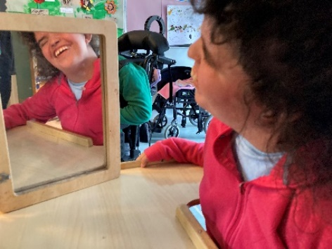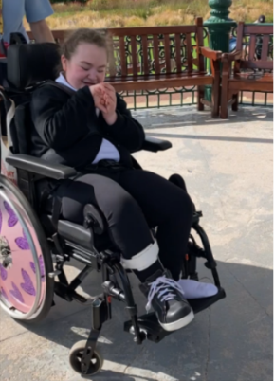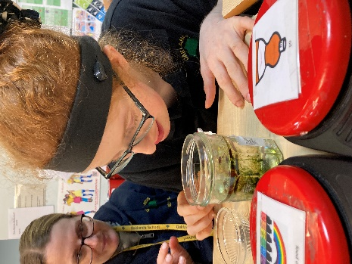

0131 315 8100 www.oaklandsedinburgh.com @Team_Oaklands.bsky.social

Religious Instruction and Observance

Parents who wish to exercise their right to withdraw their child from religious instruction and / or observance should contact the head teacher, in writing, and alternative arrangements will be made for your child.

Oaklands is a non-denominational school. Our school community includes children and staff of different cultures, faiths and those of no faith.

For us, Religious and Moral Education lies in:

- first-hand experience of faiths, ceremonies, and customs
- developing an awareness of self and others – and the world in which we live
- developing a caring, sharing attitude to others

We celebrate a variety of religious, cultural, and social events together (e.g. Christmas and Eid) and try to share in each other’s different cultural backgrounds.

We try to respect and value each other as individuals and teach positive behaviour and attitudes towards self, others and the environment.

We come together each week for a school assembly. In line with City of Edinburgh policy, this assembly is not an act of worship. Rather it seeks to develop a sense of community and to encourage pupils and staff to relate to one another – to increase sharing, understanding and tolerance in pupils and staff. We exchange news, celebrate achievement, and sing together.

Rights Respecting Schools

The rights of children and young people are at the heart of our code to practice. They are laid out in the United Nations Convention on the Rights of the Child (UNCRC). The UNCRC ensures that children and young people grow up healthy and safe and that their views are taken into considerations in decisions that affect them.
In Oaklands we are part of the Rights Respecting Schools
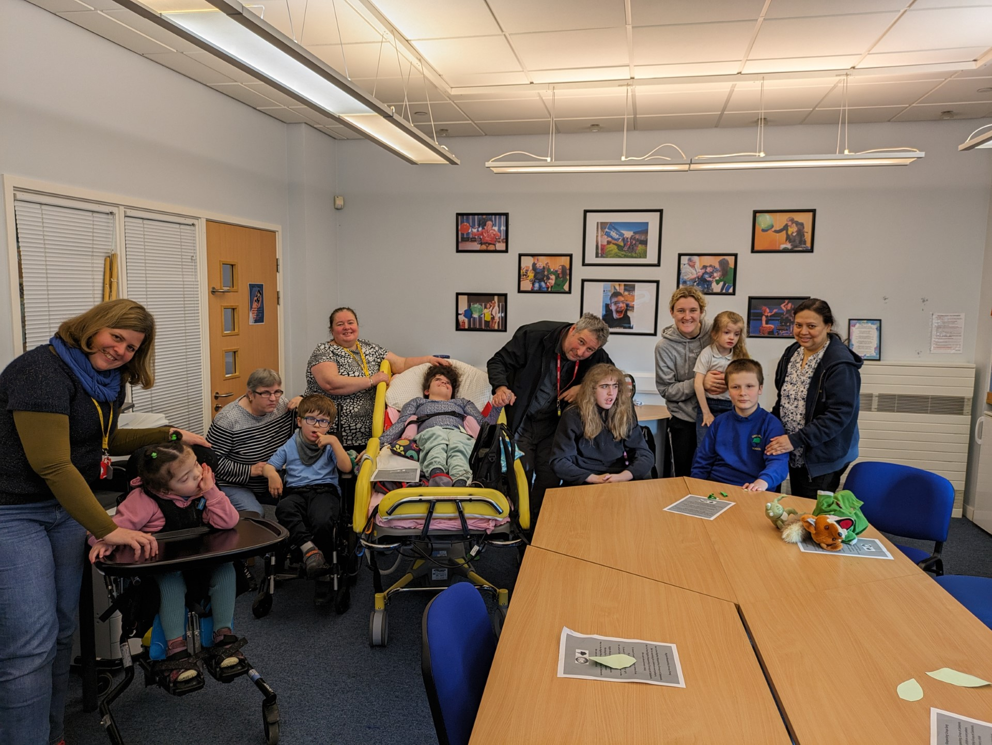
Award programme, and in May 2024 we achieved our
Bronze Award.
A Rights Respecting School is a community where
children's rights are learned, taught, practised,
respected, protected and promoted. Staff have received
training in the United Nation Convention on the Rights
of the Child, and we have a group of staff and pupils
who meet monthly to develop ways to share the rights with
their peers. We do this with stories, songs, games,
art and assemblies. We are now working towards our
Silver Award.

0131 315 8100 www.oaklandsedinburgh.com @Team_Oaklands.bsky.social

Security

The safety and security of pupils and staff when attending or working at Oaklands is very important to us.

We use many security measures including a visitors’ book, badges and escorts, while visitors are within the school building. Everybody calling at a school for any reason will be asked to report to the school office. The school staff then can make the necessary arrangements for the visit. We would respectfully ask that parents do not attempt to enter schools through another entrance, unless supervised by a member of staff.

Telephone calls to school staff should be routed through the school office. It will usually be our administrator, or one of our Family Link Workers that you speak to. They will help you to ensure your call or message is passed on to the right person. If you want to discuss details of your child’s education, the call will be passed on to the class teacher or an alternative arrangement made.

School Meals

Barbara Masterson
Kitchen Staff

Lunchtime is a very important part of our school day at Oaklands.
It is the opportunity to develop important life skills and socialise with staff
and peers.

Almost all pupils at Oaklands have an Eating, Drinking and Swallowing (EDS)
profile. This ensures they are given the correct support over lunchtime.

Our wonderful kitchen team, ensure that each child and young person receives the correct consistency of food, in line with their EDS profile.

Menus offer healthy and tasty meal options while reflecting the Scottish Governments food and drink legal requirements in both primary and secondary settings. Our menus are written to balance pupil choice with the most stringent of school food standards in the UK.
All our menus are nutritionally analysed, and new dishes trialled by pupils prior to menu launch
- All our meat is either Quality Meat Scotland or Red Tractor Assured
- All our dairy comes from Scottish Farms
- All eggs used are Free Range
- All fish is MSC certified
- We believe in sourcing food with provenance and aim to increase our spend with Scottish suppliers every year
The catering service supplies meals for pupils by following the special diet policy – more information on menus/ special diets and prices can be found here;
https://www.edinburgh.gov.uk/food-clothing/lunch-menus-schools

0131 315 8100 www.oaklandsedinburgh.com @Team_Oaklands.bsky.social

School Uniform

The wearing of school uniform is encouraged at Oaklands School.

Nursery: | Yellow polo shirt, yellow sweatshirt  Comfortable dark trousers
Primary: | Royal blue polo shirt  Royal blue sweatshirt  Comfortable dark trousers / skirt (optional)
Secondary: | Black or white polo shirt  Black sweatshirt  Comfortable dark trousers / skirt (optional)


These items can be bought in any supermarket or shop. If you wish to purchase items with the school logo, these can be ordered online from Border Embroideries.

https://www.border-embroideries.co.uk/

Several outgrown good condition polo shirts/sweatshirts/jackets are available for a small contribution.
It would be helpful if parents could send a spare change of clothing in a bag for emergency use at school.
All items of clothing and school bags should be marked clearly with the pupil’s name.

Health and Safety
Within the general policy laid down by The City of Edinburgh Council, the Education and Children’s Services Department has prepared and has continuing development of, safety policy statements for all areas of its responsibility and accordingly manages health and safety and welfare in a way that complies with health and safety statutory and regulatory requirements, and all relevant approved codes of practice and guidance.
School staff are fully instructed in their responsibilities in this respect, and safety regulations apply to all aspects of school life, both on and off the premises.
It is expected that pupils will behave responsibly and comply with all safety requirements.
The support of parents/carers in promoting good practice in health and safety matters is of great importance to the school.

0131 315 8100 www.oaklandsedinburgh.com @Team_Oaklands.bsky.social

Swimming

Swimming and hydrotherapy are one of the highlights of the Oaklands week. Each pupil needs to bring for swimming /hydro sessions in a named bag:


- 2 large towels
- swimming suit
- leak-proof swim pants (available to purchase from the school sports coach – contact office for form)
- appropriate toiletries – shampoo, body wash, hairbrush etc.

These and any soiled clothing will be returned to you for washing.

Transport to and from school

For all pupils at Oaklands, arrangements are made by the City of Edinburgh Council Children & Families Department to transport each pupil between home and school.

Parents need to apply for school transport each year. A form will be sent to parents and should be returned via email to SchoolTransport@edinburgh.gov.uk or you can fill in an online application.

Should you have any questions or concerns, please use the following contact details:

School Transport: 0131 469 2950
Travel Hub: 0131 229 2950
SchoolTransport@edinburgh.gov.uk
travel.allocationpanel@edinburgh.gov.uk

(Jack is happy to help with filling in forms/appealing transport decisions etc.
0131 315 8100 Jack.Allsopp@oaklands.edin.sch.uk)


Each pupil has individual agreed transport requirements, which are followed by contractors bringing them into school.

An escort will travel with the pupils to ensure their comfort and safety. Some parents/carers choose to transport their children to school themselves.

Parents/carers are asked to make sure someone is home to collect pupils from the transport at the end of the day.

If transport finds no one at home to receive a pupil, they will try again at the end of the round. If parents / carers are still unavailable transport advises parents / carers that pupils will be taken to the nearest Social Work Department.

0131 315 8100 www.oaklandsedinburgh.com @Team_Oaklands.bsky.social



What’s Happening at Oaklands

Here at Oaklands, we try to find as many ways to keep you informed about what is happening in school as possible.

Two of the best ways to keep up are by following us on Bluesky and signing up to our website. These are updated regularly and give you a flavour of what is happening over the course of a week. As well as reading pupil diaries every day and checking for any newsletters that have been sent home.

Find us at: www.oaklandsedinburgh.com or follow us on Bluesky @Team_Oaklands.bsky.social

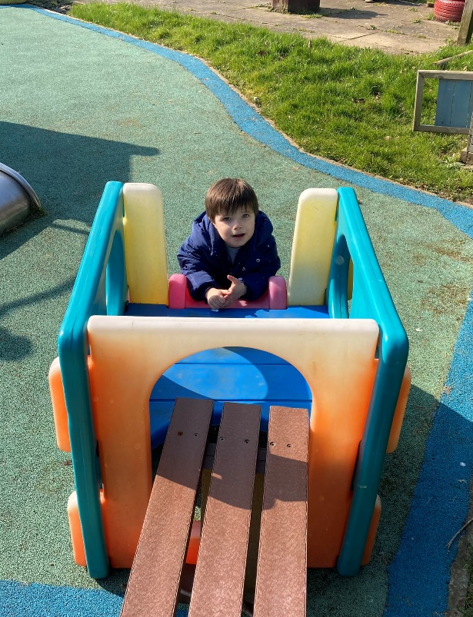
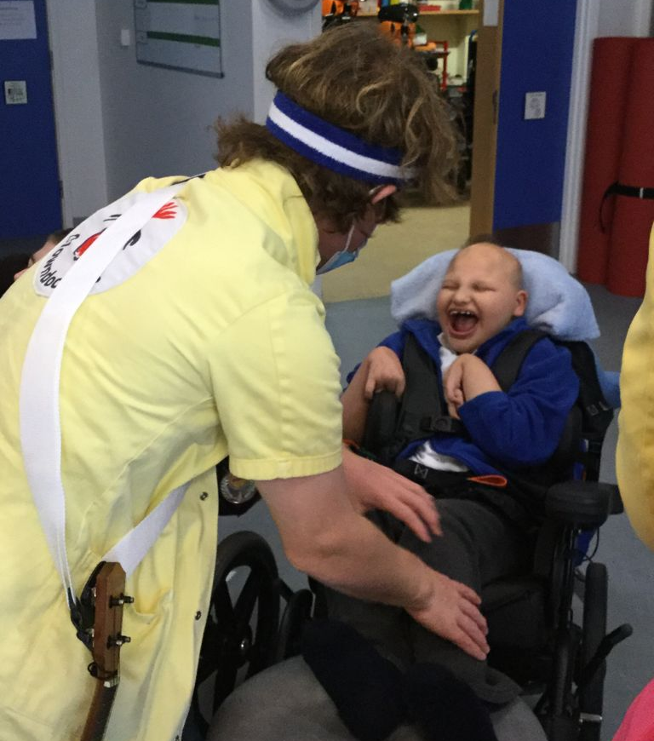

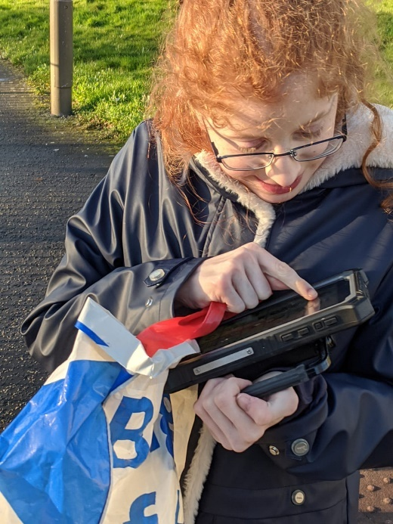
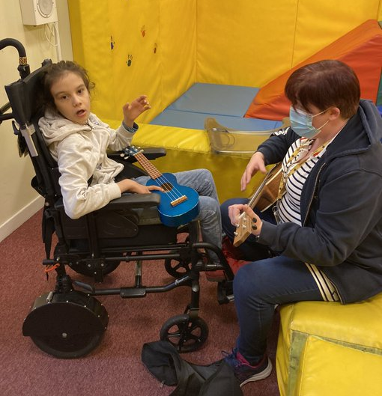

0131 315 8100 www.oaklandsedinburgh.com @Team_Oaklands.bsky.social

Useful Information
ADDRESSES:
Children & Families Department  4 East Market Street  Edinburgh  EH8 8BG  Tel: 0131 469 3000 | Oaklands School email: admin@oaklands.edin.sch.uk  750 Ferry Road website: www.oaklandsedinburgh.com  Edinburgh Bluesky: @Team_Oaklands@bsky.social  EH4 4PQ  Tel: School Office: 0131 315 8100  Tel: Medical Staff: 0131 315 8105  Tel: Therapy Staff: 0131 315 8106
Educational Psychological Services
City of Edinburgh Council
Support to Children & Young People
Waverley Court, Level 1.9
4 East Market Street
Edinburgh
EH8 8BG
Tel: 0131 469 2800

As a school for pupils with additional support needs, Oaklands School is administered by the Pupil Support Service within the Children & Families Department. Parents seeking advice or information should contact the Head of Service or the Special Schools Manager.

Special School Admissions are the responsibility of Pupil Support Services. Enquiries should be referred to your child’s Educational Psychologist.

Advice and Conciliation Service – Primary and Secondary Departments
Any parent or carer who has a complaint or problem is encouraged to discuss it with the class teacher or a member of the senior management team and usually it will be quickly resolved.

If you remain dissatisfied with the outcome of an issue dealt with by the school, you can contact the Advice and Conciliation Service, which provides a helpline during office hours to advise you on how to take further action.
The helpline number is 0131 469 3000.

You may be asked to put the matter in writing addressed to:

Principal Officer
Advice and Conciliation Service,
Children and Families
4 East Market Street,
Edinburgh
EH8 8BG

A written acknowledgement will be sent promptly when your letter has been received. Following the investigation of your letter, a full reply will be sent as soon as possible. The reply will explain the conclusion, the reason for it, any action taken or proposed and any further action you may take if you remain dissatisfied.

Advice and Conciliation Service – Nursery

Nursery complaints should be referred to The Care Inspectorate. (http://www.careinspectorate.com/)

The helpline number is 0345 600 9527 http://www.careinspectorate.com/index.php/complaints

