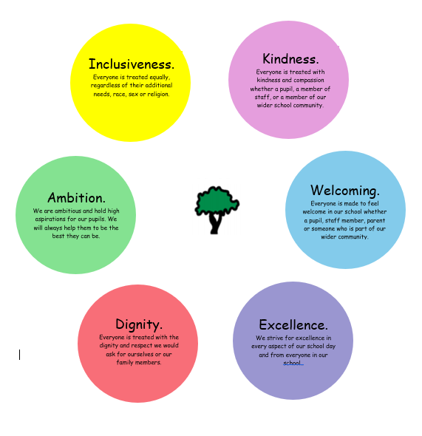
Oaklands Values
Oaklands School Vision
A place where we support our pupils to dream big, go far and unlock their potential.

Oaklands School
Teaching, Learning and Assessment
Policy

Introduction
Oaklands School provides education for children and young people with complex, long term additional support needs where the presumption of mainstream cannot be met and who require a significantly modified learning environment. Needs of learners are primarily associated with learning disability and significant visual / sensory, health and medical needs.
Curriculum
Our teaching and learning is informed by the Scottish Curriculum for Excellence. This is a curriculum for 3- to 18-year-olds. The curriculum contains four contexts for learning which are
- The ethos and life of the school as a community
- Curriculum areas and subjects
- Interdisciplinary learning
- Opportunities for personal achievement.

Our Early Years Curriculum is developed in line with Realising the Curriculum.
We have strong emphasis on interdisciplinary learning (IDL) to ensure that learning experiences take place within meaningful and motivating contexts. All of the CfE curricular subject areas (see below) are covered either through IDL or, if appropriate, through discrete subject learning.
- Expressive Arts
- Health and Wellbeing
- English Language & Literacy,
- Mathematics & Numeracy
- Religious and Moral Education
- Sciences
- Social Studies
- Technologies

Most pupils are working at the Pre-Early Milestones level of the curriculum, with a few working within the Early Level for some areas of their learning. Pupils work towards individual targets which are set within the 4 Foundation Milestone organisers below, ensuring appropriate progression and personalisation.
- Communication
- Making Connections
- Functional Movement
- Self and Emotions
Please also see our additional Curriculum Rationale document.

Learning Scope
We ensure our learning includes opportunities for
- Breadth: learning about a lot of things
- Depth: learning enough about each thing
- Challenge & enjoyment: that each pupil is stretched to achieve and a ‘have a go’ attitude is supported
- Progression of learning: ensuring enough time for consolidation so that learning is built on solid foundations
- Personalisation and choice: children making choices about what or how to learn
- Coherence: links are made between different kinds of learning
- Relevant and engaging learning: things that pupils are interested in and are relevant for their lives

Skills for learning and skills for life
We pay special attention to skills which will allow our pupils to maximise their participation and independence in everyday life, for example
- Skills in eating and drinking
- Skills in personal care
- Using timetables
- Using public transport
- Accessing community facilities and events
Planning and Differentiation
Teachers create termly forward plans for classes. The purpose of these is to make meaningful interdisciplinary links between subject areas and provide an overview of learning experiences to ensure curricular breadth and coverage. Forward planning documents have a topic-based structure as well as an emphasis on planning for literacy, numeracy and health and wellbeing. We have a rolling programme of topics based around the key Social Subjects and Science experiences and outcomes with.
Planning for pupils is fully differentiated and individualised. Termly, weekly and daily planning is informed by individual pupil’s targets and interests ensuring that learning experiences for all pupils are motivating and personalised with appropriate challenge and opportunities for success and enjoyment. Learning contexts are designed to provide opportunities for development and consolidation of pupil targets across a wide range of contexts.
Every pupil at Oaklands is unique and learning support is tailored to meet their individual needs and learning styles. Teaching and support staff know individual pupils well including knowing which communication aids and techniques to use for each pupil to ensure learning opportunities are maximised. All staff are trained in the school’s Total Communication strategies as well as other whole school teaching strategies including Gentle Teaching techniques. Effective differentiation is further supported by careful planning of class and group compositions.
Classes, Groupings and staff teams
Every class has a team of staff comprising of a class teacher and Nursery Nurses and/or Pupils Support Workers. Teachers lead on and have overall responsibility for teaching and learning within their class. Our highly skilled and trained support staff, as well as supporting teaching and learning, are encouraged to lead on specific areas of learning under the direction of the teacher.
Our Nursery team is made up of a Senior Early Years officer, a full time Nursery Nurse, and full or part time Pupil Support Workers.
In addition, we have input from our Sports Coach, our Rebound Therapists and two Performance Arts teachers.
Class teams are designed to meet the particular needs of each class. Staffing numbers in each class team may vary depending on the size of the class and the needs of the pupils within that class.
Our pupils are taught in multi-stage classes. The makeup of these is informed not only by age but also on the needs and abilities of the children and young people. We aim to keep our pupils within the primary or secondary department, but sometimes we may have a combined upper primary/lower secondary class.
Our pupils are taught in a variety of groupings.
- Whole class – where everyone is participating in an activity – e.g. Circletime, Art, Story time.
- Small groups – where 2-4 children may be working together on similar targets – e.g. communication group.
- Larger groups – where more than one class works together – e.g. for performances and shows.
- Individually – where a pupil works with a team member or therapist on individual targets – e.g. Intensive Interaction.
- Whole school – where we come together to celebrate and find out what our friends have been doing – assembly.
The Learning Environment
Our Vision Values and Aims set out our whole school expectations and aspirations and inform all areas of school life including the learning and teaching environment. Staff, pupils, families and partners are all part of this collective vision. Expectations and guidance for learning environments are further clarified in our ‘Great Practice at Oaklands Graffiti Board’ which is shared with all classroom staff and provides the basis for conversations, observations and evaluations of learning and teaching.
Career Long Professional Learning
To support effective teaching and learning, teachers are encouraged to undertake CLPL linked to the four areas of the Teacher’s Charter, Formative Assessment, Differentiation, Skills and Leadership of Learning, that is relevant to our context and pupils. We also provide a comprehensive programme of year-round in-house training for all staff so that they all have the necessary skills & knowledge to effectively support our young people and to ensure a continuity and consistency of approach.
Assessment
All pupils’ individualised long-term targets are set at the end of the academic year ready for the start of the next academic year. Targets are also updated at other points in the year if required. Teachers, support staff, parents and the AHPs are all involved in setting these targets.
At the start of each term, the long-term targets are broken down into short-term targets. Short-term targets are evaluated at the end of that term and used to inform the next term’s short-term targets. Long-term targets are evaluated at the end of the academic year, or sooner if required, before new targets are set.
Our assessment is based on formative assessment processes, primarily observations by teachers and support staff. Pupils’ progress towards targets and other areas of learning is continually monitored and recorded by staff teams. Weekly class team meetings facilitate discussions about progress and allow appropriate tasks and challenges to be set.
Awards & Qualifications
We have a number of award programmes running across our school allowing for some external validation of our assessments. Our senior pupils follow courses within the SQA National Qualification Framework which provide opportunities for learners to develop their knowledge and skills at an appropriate level, and to have their achievements certificated. Each pupil within the Senior Phase will study a range of units and awards depending on their individual skills and interests. Pupils from S3-S4 work towards SQA Personal Achievement Awards. See the award structure below for details of progression through the school.
Pupils in S3 upwards have the opportunity to work towards the Duke of Edinburgh Award. DofE provides a structure which encourages and supports pupils to develop their skills and interests under the three areas of Skills, Physical and Volunteering. There is also the opportunity to take part in an Expedition to develop outdoor adventure skills and experiences. Our upper primary pupils take part in The Junior Award Scheme (JAS). This is an accredited award for young people which corresponds with the goals of the Curriculum for Excellence and is designed to support progression onto the Duke of Edinburgh Award. JAS is designed to be flexible and adaptable, matching the interests and abilities of individuals, to ensure it is achievable by all participants. JAS is structured into four sections: - My Interests – developing a new hobby, Get Active, Stay Active – taking part in sport and physical activity, Me and My World – a community or nature based project, Adventure – outdoor activity and learning, including teamwork and problem solving. Pupils progress through White, Green and Gold levels.
Oaklands Awards Structure:
Nursery
P1 | RSPB – wildlife Challenge Activities
P2 | RSPB – wildlife Challenge Activities
P3 | RSPB – wildlife Challenge Activities
P4 | JAS – White
P5 | JAS – White
P6 | JAS – Green
P7 | JAS - Green
S1 | JAS - Gold
S2 | JAS - Gold
S3 | SQA – Personal Achievement Award (3 units – 1 or 2 per term)  Register for and start DofE – aprox. 1 hour per week
S4 | SQA – Personal Achievement Award (3 Units – 1 or 2 per term) – Leading to completion of Bronze, Silver and Gold over two years (2 units per stage)  DofE – aprox. 1 hour per week
S5 | SQA Nat 1/Nat 2 (1 or 2 per term + optional additional ones in Sports/PA?)  DofE – aprox. 1 hour per week
S6 | SQA Nat 1/Nat 2 (1 or 2 per term + optional additional ones in Sports/PA?)  DofE (inc. residential trip?)

Outdoor Learning
We aim to provide as many varied and stimulating contexts for learning as possible. We strongly support and encourage Outdoor Learning for all curricular areas, and all pupils take part in outdoor learning several times per week.

Digital Learning
All classes have access to iPads and, when appropriate, pupils have individual iPads. These are used to support learning in different curricular areas according to the needs and abilities of the pupils. All classrooms have Interactive Whiteboards to support teaching and learning and many pupils have personalised electronic communication aids and are supported to use these across the curriculum.

Home Learning
We have a comprehensive range of lessons and activity ideas for all curricular areas on our school website to support home learning if needed. If a pupil is in hospital for any length of time, their class teacher will liaise with the hospital teachers to ensure that a cohesive programme of learning can be supported effectively during their stay. If a pupil is absent for an extended period, then individual supports are put in place to meet the needs of the pupil and families.

Reporting Progress to Parents
We report to parents annually in end of year reports issued in May. In addition, parents are invited to and receive minutes from annual CYPPMs. These meetings include input from all the services engaged with their child. There are two opportunities for parents to formally meet with their child’s teacher, in November and in May. Parents can opt for a phone meeting if that suits them better. Parents and carers are actively encouraged to participate in school life and to come in at other points in the year. There is daily home-school communication and parents are able to contact their child’s teacher informally with any requests, concerns, questions or information.
Reviewed November 25 Next review November 26

