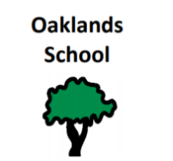
City of Edinburgh Council
Children and Families Department

Oaklands School,
www.oaklandsedinburgh.com 750 Ferry Road,

@team-oaklands.bsky.social Edinburgh EH4 4PQ

Email: admin@oaklands.edin.sch.uk Head Teacher: Rebecca Vaughan Tel: 0131 315 8100

Dear parents/carers,
Oaklands School are looking forward to having lots of fun on the lead up to Halloween. Classes will be listening to the story ‘Room and the Broom’ by Julia Donaldson. You may wish to listen to this story at home too. You can watch it following this link https://www.bbc.co.uk/programmes/p0102qfj. Your young person will be taking part in a literacy walk around school, listening to and exploring aspects of this story through sensory opportunities. During this week we will also have a pumpkin carving competition, a chance to ‘Trick or Treat’ and other sensory and fun activities planned.
All children and young people are invited to dress up on Wednesday 29th October. We will be having our school Halloween disco on this day, and learners will enjoy dancing and taking part in Halloween themed games.
It’ll be great fun, and we are looking forward to it.
Thank you,
Oaklands Teachers

