Duke of Edinburgh
at
Oaklands



What is Duke of Edinburgh?

- Duke of Edinburgh is a programme that encourages young people to have fun, explore exciting challenges and develop their skills and interests.

- There are 3 levels within Duke of Edinburgh: Bronze, Silver and Gold.

- Any young person can take part in Duke of Edinburgh as it is all about setting personal goals and pushing individual boundaries.

- Although there is a lot of work involved in the programme it will be full of lots of fun too!

What are the benefits of doing Duke of Edinburgh?

This will be an opportunity to:

- Learn new skills
- Experience new adventures
- Develop new interests
- Take on some responsibility
- Develop key life skills

What will this involve?
- Bronze Award is the first stage.

- There are 3 sections within this: Skills, physical and volunteering.

- We will work on each section over 3 months and then select one of the 3 to extend to 6 months. The one we select for 6 months will be based on the young person’s interests and motivations.

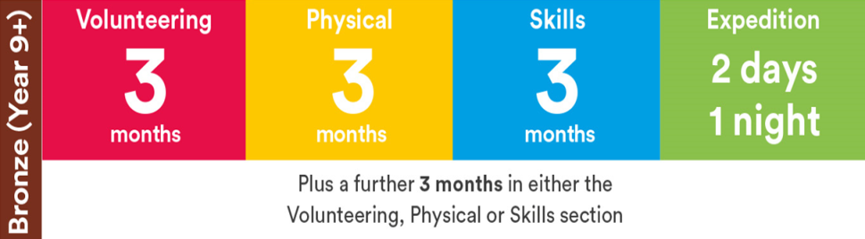

- There will be an expedition towards the end of the programme.

- We will look at all of the sections in more detail when we create an individual plan for your young person.

The 3 sections: Skills, Physical and
Volunteering
- Each of these sections will be worked on during school time so there is no need to worry about completing activities at home, unless you really want to and then that would be great!

- The individual plan we create will have details of the activities your young person will be working on for each part. Here are some examples of activities that can be explored:

*Skills – bath bomb making, growing vegetables, photography, craft, circus skills or cooking

*Physical – bowling, dancing , Rebound, adapted bike use, or Boccia

*Volunteering – litter picking, helping in a library, supporting a charity, helping organise school events or fundraising

- There are lots of options for each of these sections so we will find something that is just right for everyone.
The Expedition

- A standard DofE Bronze Expedition involves 1 overnight stay and 2 days of activity - 6 hours each day. But Duke of Edinburgh are very flexible and want the award to be as inclusive as possible.

- There are lots of variations possible, for example, we can plan an expedition over 3 days to fit within school hours without the need to stay late. Individual plans for the expedition will be developed closer to the time taking into account the needs and wishes of the young person and their families.

- The activities can be absolutely anything that is motivating for the young person taking part. Previous expeditions have included a walk across the Forth Road Bridge, a cycle trip through the Colinton Tunnel, explorations of the Pentlands and beach wheelchair adventures.

- There will be lots of stops along the way to have a rest, a snack and some favourite activities.

Does my young person need to take part in all sections of the Award?

- There is a separate award for each section of the programme. This means if your young person only completes one part, such as the Skills section, they will still receive an award for this. They do not need to complete every section.

- If you are worried about the expedition section in particular, this is not compulsory, and the young person can still complete the other sections.

- For young people who complete all 3 sections plus the expedition, they will receive the full Bronze award.

Are there any costs?

- Oaklands pupils are currently eligible for full financial support to cover the enrolment fee which is £31 for the Bronze Award. So there is no cost to you.

- We will be fundraising in school to help cover any costs associated with the expedition.

- Enrolled young people receive a DofE discount card which can be used in a number of outdoor shops.

The Journal

- Each young person will keep an online journal of their adventures along the way through their eDofE account. This will include lots of photos of their activities during each of the 3 sections and of course the expedition too. You can access this at home to see what they’ve been up to. You can also add updates from home of you want to,

The Award Ceremony
- It will take around 12-18 months to complete the full programme for the Bronze award.

- At the very end of this we will celebrate all the young people who have taken part as part of our Awards Ceremonies. This will include those who have completed only parts of the programme as well as those who have worked towards the full award.

- This will involve inviting family to join us to look back over their journeys and celebrate all their amazing achievements.

- We will possibly invite along some of the Duke of Edinburgh staff who have supported us in our journey so they can see all the amazing experiences everyone has taken part in.

- We will present the Bronze Award and individual section awards to everyone at this event.

What happens next?
- You will need to sign a permission form to say you are happy for your child to take part in the Duke of Edinburgh Bronze Award programme.

- Once pupils are signed up, we will create an individual plan for each young person. This will involve thinking about ideas for the 3 sections, Skills, Physical and Volunteering. We usually create this based on the preferences and skills that we see them demonstrate in school, but please let the class teacher know if you have ideas for these.

- We will be starting our work towards the award as soon as this plan is made.

- You will get regular updates via your young person’s eDofe account about the progress your young person is making within their own programme.

Other information
- The Duke of Edinburgh Leaders for the Award in Oaklands will be Aryadaya Thomson and Sharon Humble. You can get in touch with us at any time to chat about the Award and discuss any ideas or concerns you might have.

- We will be working on DofE activities most weeks.

- Please complete the paper copy of the permission form and send back into school. This will just allow us to add everyone to the Duke of Edinburgh system.

- Please get in touch if you are unsure in any way or would just like a bit more information. You will be fully involved in every step of the programme and will be able to change or remove any section at any point so we will be in regular contact throughout the year.

Contact details
School phone: 0131 315 8100
Aryadaya Thomson
email: aryadaya.thomson@oaklands.edin.sch.uk
mobile: 07874641118
Sharon Humble
email: Sharon.humble@oaklands.edin.sch.uk

Website for Duke of Edinburgh
https://www.dofe.org/

