- Colour you bottles as above then leave to dry.
- Take time to have fun watching the paint make patterns as it merges.
- Remember to add glue to help the paint stick to the plastic.
- With help cut the bottles from the bottom up to make spirals.
- Hang them up and watch them move and twirl.

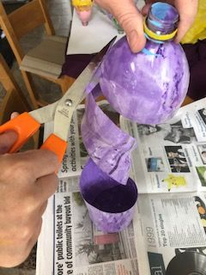
- Pour different colours of paint into your bottle and move the bottle to watch the colours merge. Remember to put the lid back on first! What noises can you make from squashing, shaking your bottle?
- Make as many bottles as you like, string them together and hang outside or maybe in your bedroom?
- Can you make a rainbow?
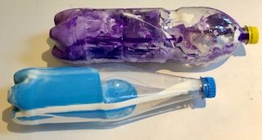
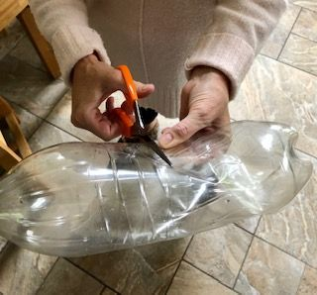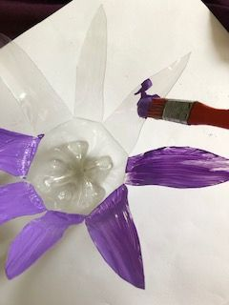
- How many plastic bottles can you find?
- With help cut into the bottle from the side then cut petal shapes.
- Add some glue to your paint and decorate your flowers in your chosen colour.
- What can you put in the middle? Paint, tissue, fruit nets? You choose!

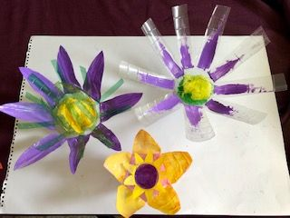
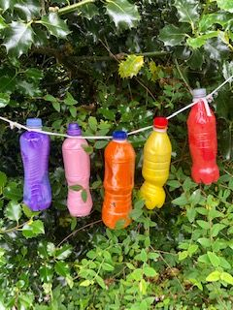
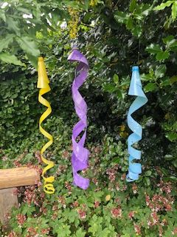
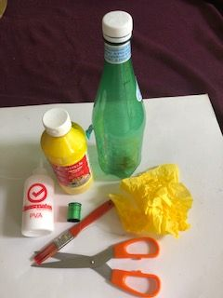
Materials needed:
Plastic bottles, paint, glue, paintbrush, scissors and string, wool or thread.
Optional – tissue paper
Art Activity – Plastic bottle creations - (Home Learning)

