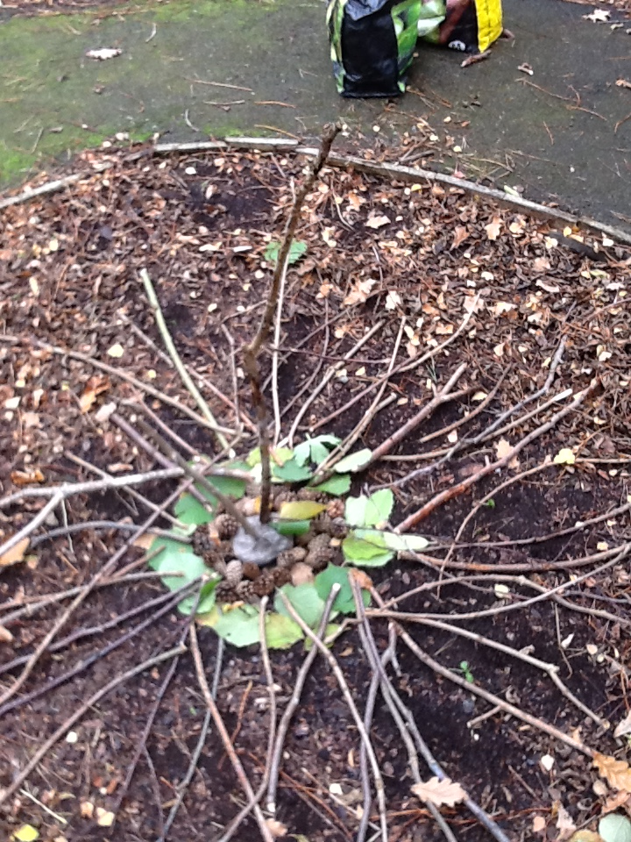
- How many different shaped and coloured leaves can you find? Try and collect some next time you are out for a walk or maybe from your garden? You might want to find and use other natural materials also.
- Explore your collection. How do the items feel? Hard, soft, jaggy? How do they smell?
- Tape some string, thread or wool to a pencil and thread all your leaves. How long can you make your leaf string? Can it reach across your garden or room?

- If you have some dough, clay or plasticene why not make your art work on a tree or other hard surface?
- You can have fun with twigs.
- Why not try to make a sunburst, or throw your materials randomly and see what patterns they make.
- Just make sure to have fun

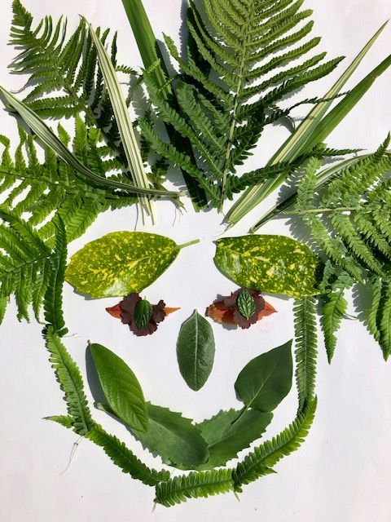
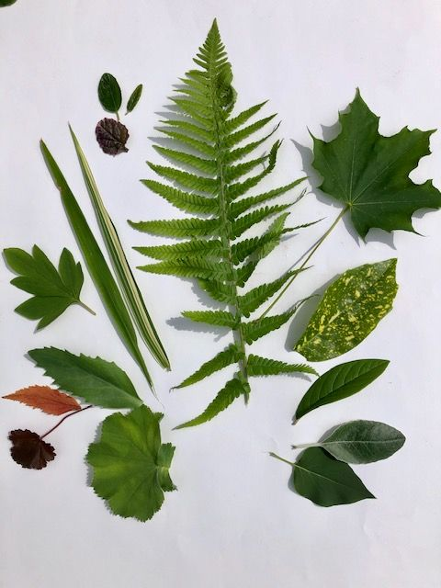
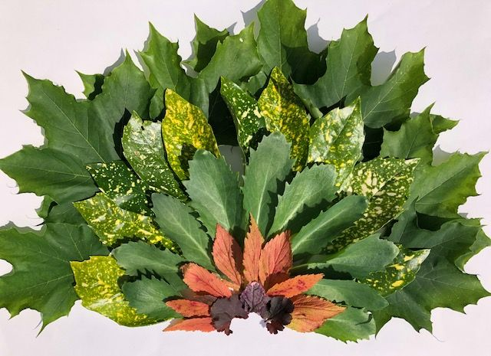
- Can you make a rainbow or maybe a fantasy creature?
- Can you make different shapes- circles, squares, triangles? What about adding a pebble or twig border?

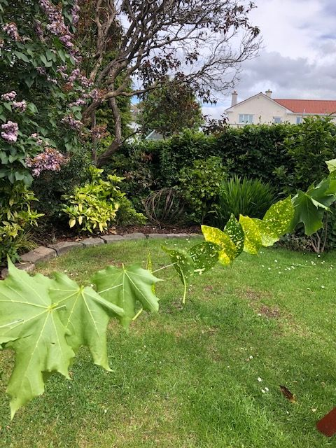
- How about making a face.
- Does your face have crazy lockdown hair?
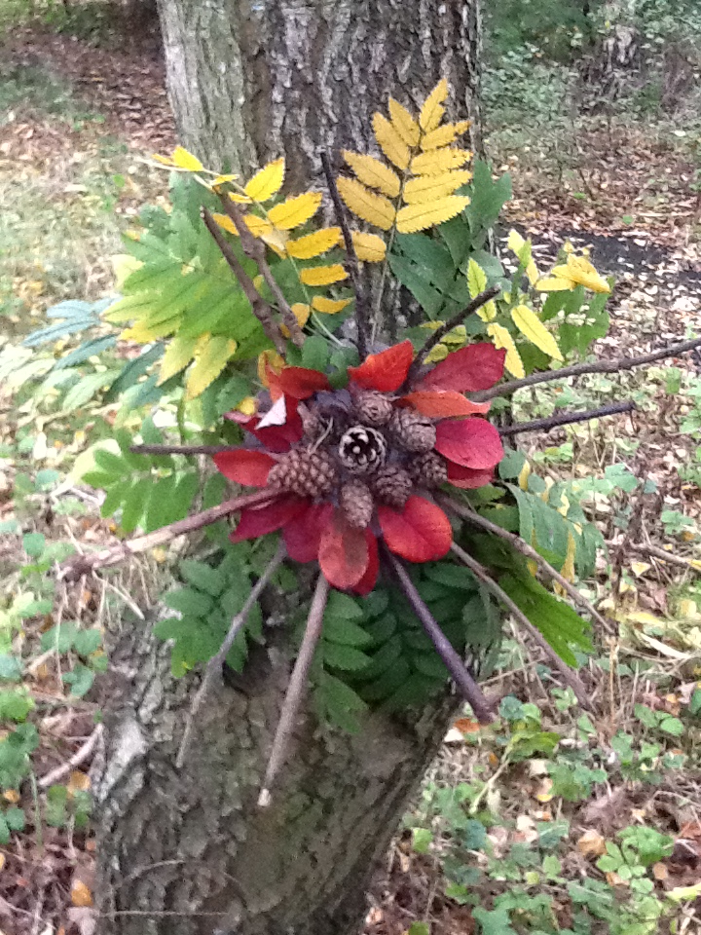
Using prit
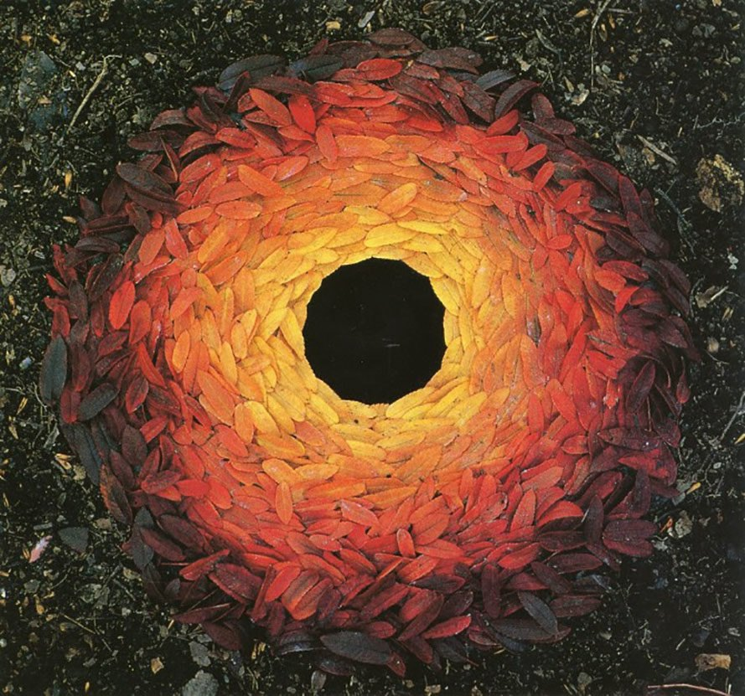
Andy Goldsworthy

Art Activity – Leaf Creations
(Home Learning)
- Have a look at the work of the artist Andy Goldsworthy to inspire you.

Materials needed: Natural materials such as –
Leaves, stones, twigs, pine cones.
Pencil, sticky tape, and string/thread/ wool.
Modelling material (optional)

