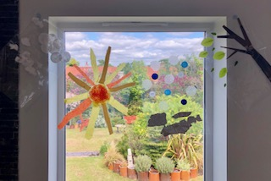
- Glue plastic lids, tin foil and bubble wrap, or any other related materials to make your rainy picture.
- Have fun finding and exploring all the different materials. When you’re finished try layering the pictures on top of each other, see below.
- Finally hang your work on a window for everyone to enjoy.
- Cut out or tear a tree trunk and branches and glue in place. Use real leaves or cut out paper leaves and glue down.
- Try and make your leaves look like they are blowing away when creating your windy picture
- Use scissors to cut open your poly pocket or alternatively use paper to work on.
- Use fruit nets and tissue or coloured paper to make your sun. Glue onto you polypocket/ paper using a glue stick or PVA.

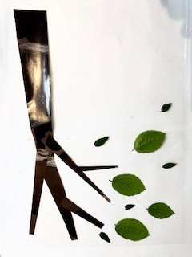
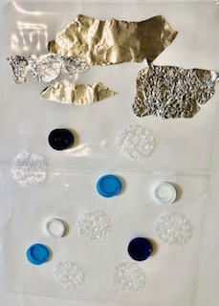
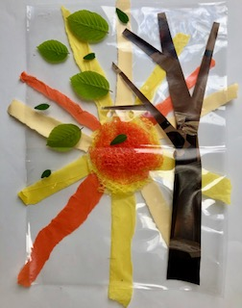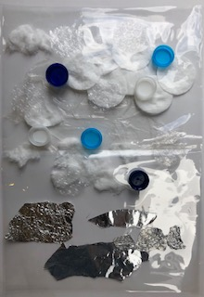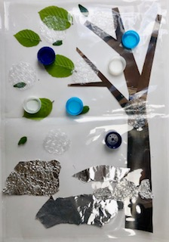

Using prit
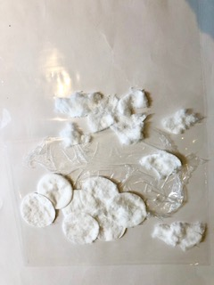
- Use cotton wool and recycled plastic or any other white materials to make your cloudy picture.
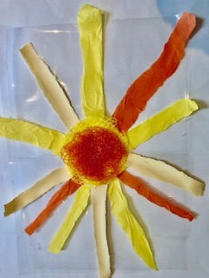
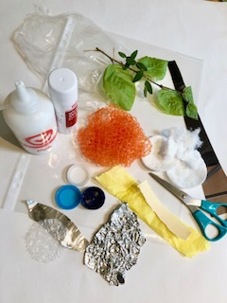
Art Activity – Weather Windows
(Home Learning)
Materials needed: Poly- pockets or white paper, Glue, scissors, found objects such as - cotton wool, tin foil, plastic lids, tissue/ coloured paper, magazines, leaves, bubble wrap, fruit nets.

