- Collect and explore the materials you are about to use. Do you have a flower to look at? How many petals does it have?
- Choose and mix your paint colours. Add white paint if you want pastel colours.
- Dip the objects into the paint one at a time and have fun printing lovely flowers with different shaped petals.
- Use the card to make some stems or/and grass. Do you want to add a sun?
- Have a look around your house and find different materials to experiment with.
- Please share/ post your flower pictures to brighten everyone’s day!
- Do you want to add a sun?
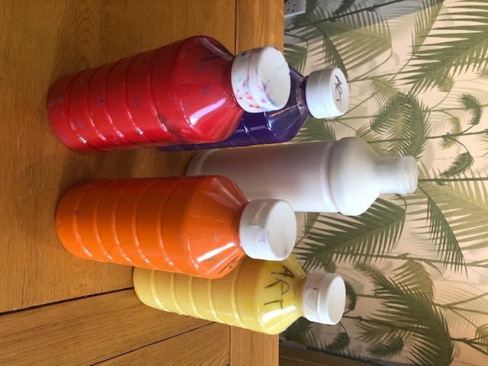
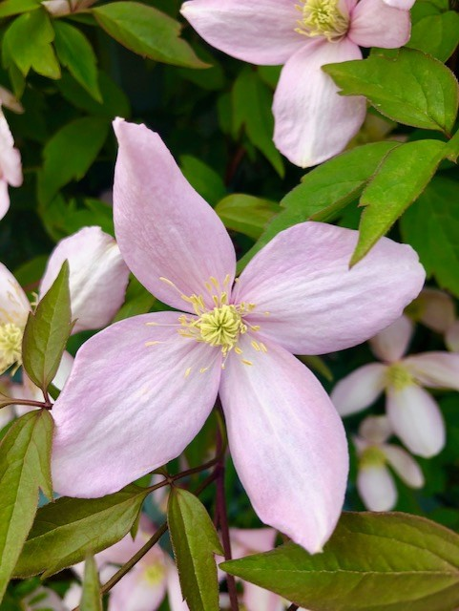
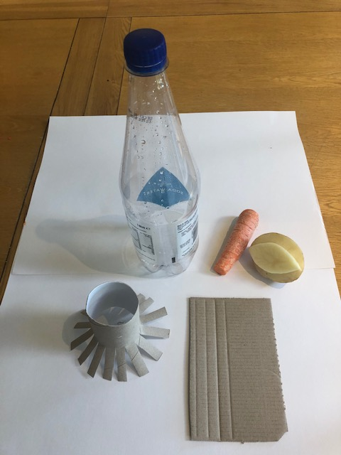
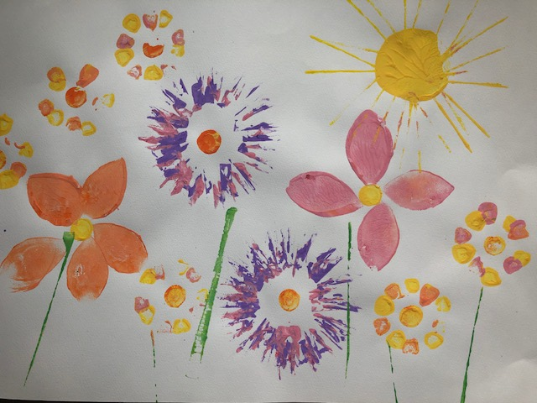
Materials needed: Paint, potato cut into petal shape, carrot cut at one end, toilet roll tube cut/snipped at one end, plastic bottle, card strips.
Art Activity - Printed Flowers (Home Learning)

