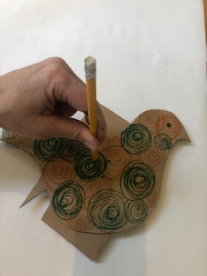
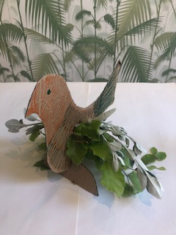
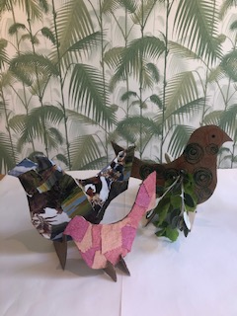
- Thread the materials through the holes to make your wings.
- Add the small card semi circles (with slits) if you want your bird to stand up. Alternatively hang your bird inside or out as a mobile.
- Why not make a flock of birds using any materials you like to decorate them such as: Bits of torn magazine, small bits of fabric, sweet papers, paint, the list is endless!
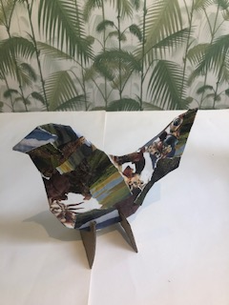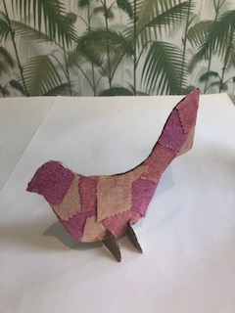
- Use scissors to cut out a simple bird shape, use any old cardboard.
- Cut out 2 small semi circles with slits if you want your bird to stand up.
- Decorate your bird with pens or crayons.
- Use a pencil to make holes for the wings. Sit the bird on more card to protect your table.

- Go on a hunt outside to find something to use for the birds’ wings – Leaves, twigs etc.
Or alternatively use folded paper as wings.

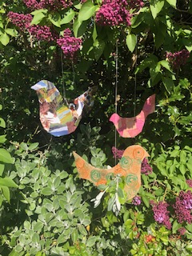
Materials needed:
Card, scissors, pens (sorry not in photo!), leaves or twigs.
Optional – magazine, glue, fabric, thread or string.
Art Activity – Birds -Models/Mobiles. (Home Learning)

