
City of Edinburgh Council
Children and Families Department

Oaklands School,
750 Ferry Road,
www.oaklandsedinburgh.com Edinburgh EH4 4PQ

Email: admin@oaklands.edin.sch.uk Head Teacher: Morna Phillips Tel: 0131 315 8100

Parent Council Meeting - Wednesday 21st March at 6.30 (@ Oaklands)
- Carol Chalmers attending to discuss Playscheme

Tuesday 20th March 2018

Dear Parents, Carers and Friends of Oaklands,
It was lovely to welcome the children and staff back to school after the February break only to have the term disrupted by but the snowy weather. When the clocks change this weekend, we’re hoping for sunshine all the way to the end of June!
With the school closed, it meant the cancellation of our World Book Day Celebration. We’ve rescheduled for this week and sent out updated invitations at the end of last week.
We would be delighted to welcome parents and guests along to the launch of our four sensory books, (designed by author and storyteller Ailie Findlay), this Thursday at 10am.

Pupils:
We are delighted to have some new pupils joining us at Oaklands after the Easter break. We will be welcoming two new pupils to the nursery and one new pupil is moving from Aberdeen to join us in Class 3.
Staff News:
We have been busy recruiting to some key vacancies and have appointed Fiona Smith to the role of permanent Principal Teacher, from a very high calibre field of candidates.
We also held interviews for a permanent Class Teacher post and are very pleased that Clare Warwick was our successful candidate and will be transferring from the St Crispin’s team. Clare will be joining S1-3 as their new teacher after the Easter break.
We’re absolutely delighted to welcome Fiona and Clare to the Oaklands staff team on a permanent basis and know that they will continue to be real assets to the school team.
We’ve also appointed 4 new Pupil Support Assistants for the summer term. The new PSAs will be covering some staff absence and also to assist classes with our new pupils and to help them settle quickly into our school.


Updating School Vision and Aims:
Over the course of this term the staff team have been working to update our school vision and aims statements.
We will shortly share our initial thoughts with parents and the wider community to ensure everyone’s views are sought before finalising our statements.
School Community Events:
Ceilidh Night:
Thanks to all who attended Oaklands, first ever, Family Ceilidh on Friday 23rd of February.
It was a wonderful evening, attended by staff, pupils families and friends. We were lucky to have great music from the Columcille Party Band who ensured that everyone was up and dancing!
Haggis, neeps and tatties were prepared and served up by Barbara and Dot in the school kitchen, who gave up their time to support this wonderful event for our school community. Barbara and Dot are somewhat unsung heroes at Oaklands but are an invaluable part of our school team. The evening wouldn’t have been possible without their commitment and support for the school.
We hope everyone who attended enjoyed their evening as much as I did!
Race Night:
We still have a few tickets left for our Innowalk fundraiser Race Night, this Friday night. Please contact the school asap if you’d like to buy tickets, a horse or even sponsor a race!

Innowalk – Fundraising:
Thank you to everyone who has supported our fundraising campaign so far.
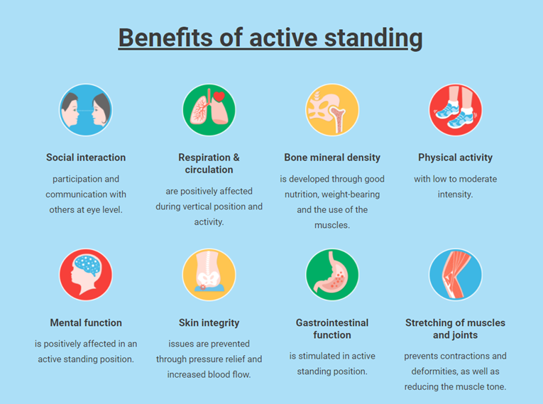
We’re delighted to be the first school in Scotland to purchase an Innowalk Pro machine. The machine was on the way from Norway last week and has now arrived in the UK. It is having some further adaptations made to it and we’re hoping it will be with us by the end of the month!!

We are currently in the process of fundraising to purchase another (bigger size) machine for use with some of our secondary pupils.
Our total is currently sitting at just over £7000.

We really have been pushing fundraising over the past few months and have a committee in school that have been organising /leading these events.
Our next fundraiser is a Virtual Marathon Festival starting on the 28th of March (further details below).
It has been a huge undertaking to commit as a school to the purchase of two very specialised items of equipment. We think that they will make a significant difference to the lives of many of our children and young people and are proud of our collective effort so far.
We have (just about) secured charitable status (thanks to our Parent Council Chair Elaine Weir for her tireless efforts). This should make a huge difference and will allow us to make applications to trust funds for donations towards this very worthwhile cause.
In the meantime, if you are able to support our current events; the Race Night this Friday and then the Virtual Marathon Festival (VMF) – personally, through friends or work places, it would be greatly appreciated.
We promise to concentrate our efforts into our applications to Trust Funds after these!

RUNNING SHOES AT THE READY?
As spring and summer beckon us, would you like to…
…get you/your friends/your family fitter for the summer?
…earn a bit of bling?
…help Oaklands School raise money for an amazing Innowalk?
We are holding a Virtual Marathon from 28th March to 22nd April, and asking you and yours to take part, for a donation of £10.
You don’t need to run a marathon in one go, but you do need to make sure that you cover the distance of a marathon (26.2 miles) over those 26 days. By finishing on 22nd April, you can celebrate with the London Marathon runners that day!
Click on the news page on our website and you will be able to share information about this event via twitter or Facebook. The hope is that our families are able to encourage friends or family members to take part in this fundraising venture! The entry fee is £10 (no sponsors) just the entry fee and you’ll be set to go!
Thanks in anticipation of a great VMF.
Ready…..steady…….

School Placement Session 18-19:

I have recently been involved in discussions with Educational Psychologists and Senior Council Officers on placing requests for Additional Support Needs Schools for session 18-19.
Letters offering places will be sent to parents once the meetings have been completed. We will then put plans in place for the new pupils and new classes for the start of school session 18-19.

Review Meetings:

We are just about finished our programme of annual reviews. It has been fantastic to meet with families and other agencies involved in the care and support of our children and young people. We hope you find these meetings valuable and would welcome any feedback and any ideas you may have on how to improve our service.

Pool Works:
This year we have had a number of different repairs on our pool and we’re delighted that it is now back in use. Our physios have reinstated hydrotherapy sessions and Sharon Humble, our Sports Coach has reinstated our school swim sessions. These sessions really benefit our children and young people. We really have missed the use of our pool and are so glad its back in use!

Things to look forward to:

- World Book Day sensory story book launch -Thursday 22nd March 10am
- Easter/Spring Fun Activity Session -Thursday 29th March 10am
- MOVE DAY -Wednesday 16th May
- Sports Day -Tuesday 5th June

Dates for your Diary:

- End of Term – Last day for all pupils and staff | - Thursday 29th of March
- Staff and pupils return | - Tuesday 17th of April
- Parent Consultations | - Thursday 3rd May
- May Day Holiday – SCHOOL CLOSED | - Monday 7th May
- Staff in-service – SCHOOL CLOSED | - Tuesday 8th May
- Victoria Day Holiday – SCHOOL CLOSED | - Monday 21st May
- Transition afternoon - | - Wednesday 20th June
- Awards Ceremony - | - Wednesday 27th June

Oaklands is always a busy and exciting place with whole school assemblies, family events, music students, expressive arts volunteers, theatre productions, dance base instructors in school, visits to the Yard, Clown Doctors, Holyrood Challenge, Molly our cockapoo therapet and a whole lot more.

Please do keep an eye on our website so that you can stay up to speed with the current goings on at Oaklands! www.oaklandsedinburgh.com

I hope to see some of you at the Parent Council meeting tomorrow and if not, I hope everyone has an enjoyable time over the Spring Holiday.

Happy Spring Equinox! We’re already looking forward to a busy Summer Term ahead.

Kind regards,

Morna

Morna Phillips (Head Teacher)

